How To use Drone To Paste/Hang Solar Lights Devices To High Walls
This is a guide for how to use a drone to hang/paste solar LED to high walls. The technique can be used to hang almost any device as long as it is light enough to be carried by the drone. Solar cell-powered LED lights are a good use case since they are charged by the sun and don't need charging.
A full guide is given in the attached video.
https://www.youtube.com/watch?v=dzbp8P41iN0

This is my second tutorial and is part of a project of trying to hang everything everywhere with drones. The previous approach is simpler and works with smaller drones (MINI 2) but can carry less weight and the sticking is less strong than the approach described here. The current approach was tested with DJI AIR 3 and AIR 2 (AIR 3 works much better).
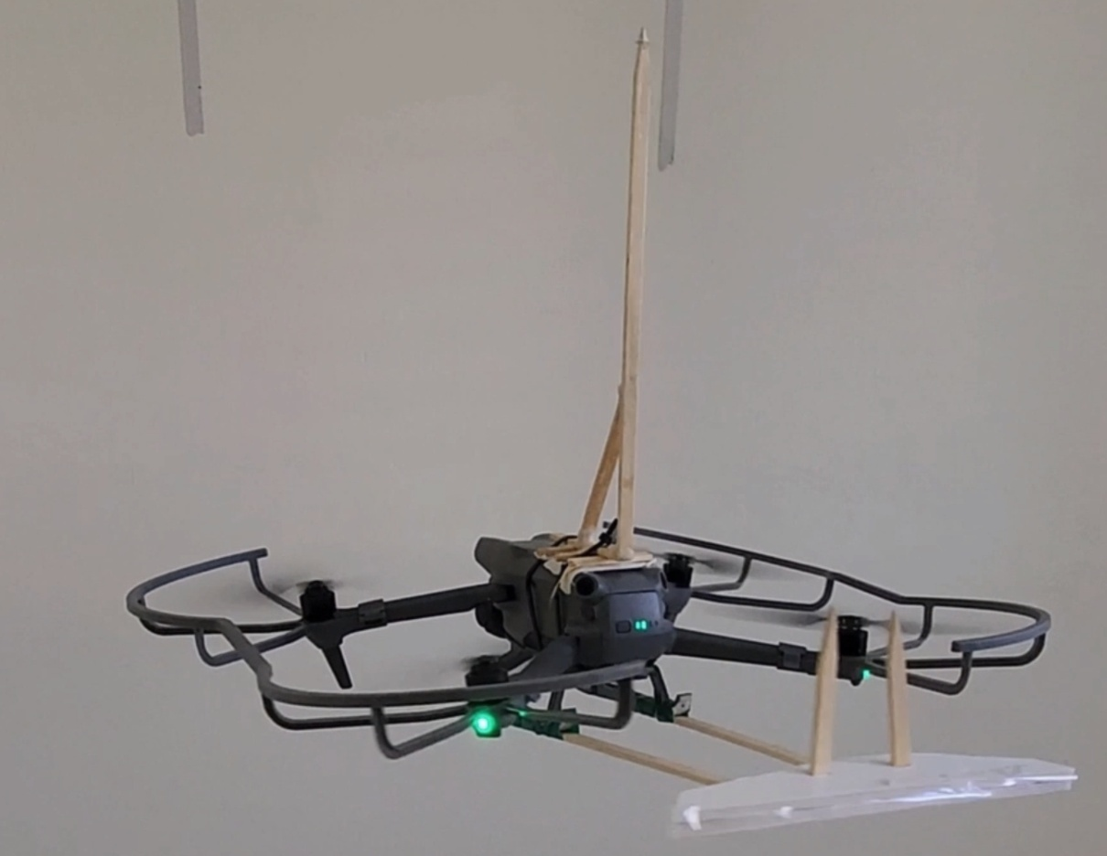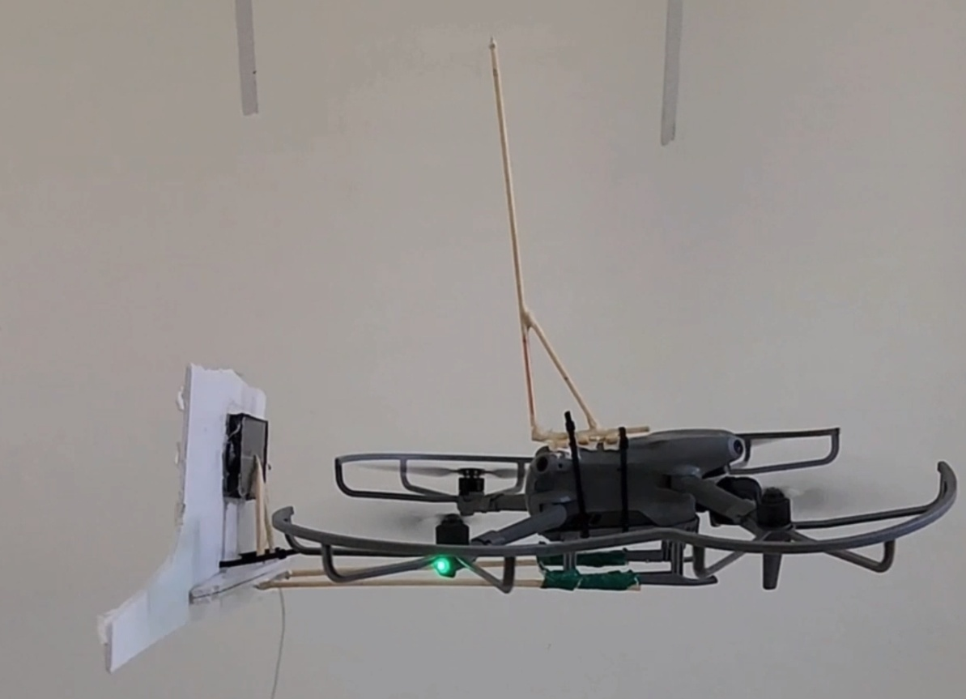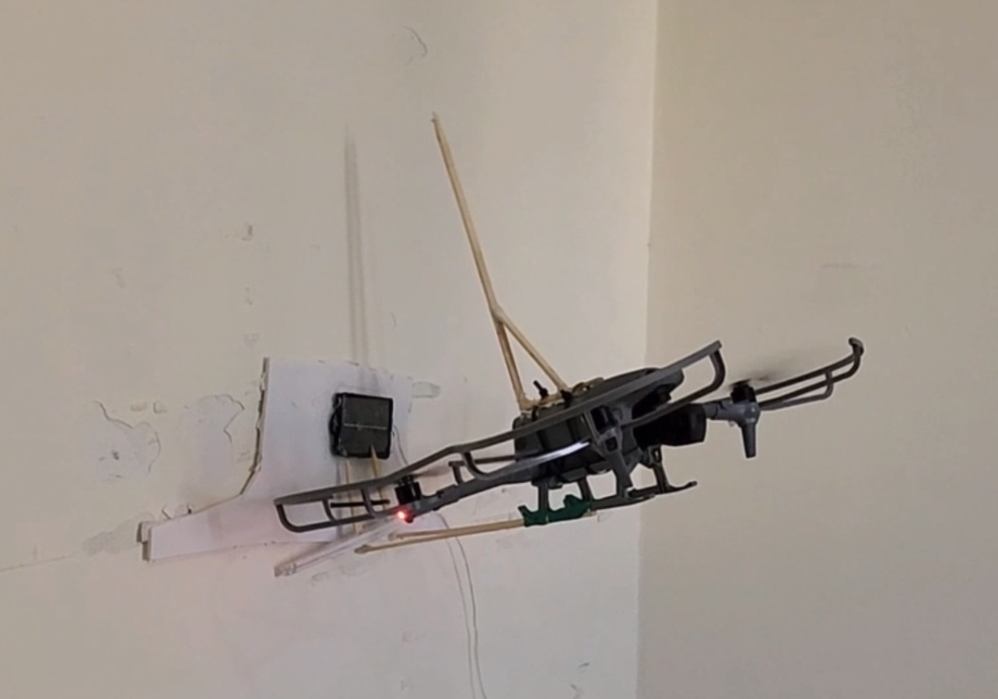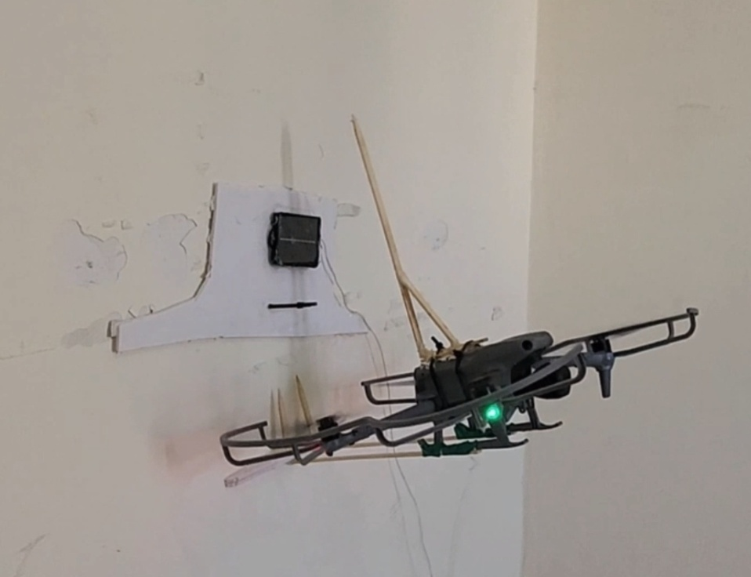

Outline

The outline of the technique is as follows:
a) Attach the solar LED device to a flat plate, on the other side of the plate add double-sided sticky tape, and on the front, we add a loop that will be used to hang the plate on the drone.
b) Attach an L-shaped hook to the drone. This will be used to hang the plate in front of the drone.
c) Once the plate hangs on the drone, fly to the target pushing the plate to the wall. Once the plate has been stuck to the wall, descend downward releasing the drone and leaving the plate attached to the wall.
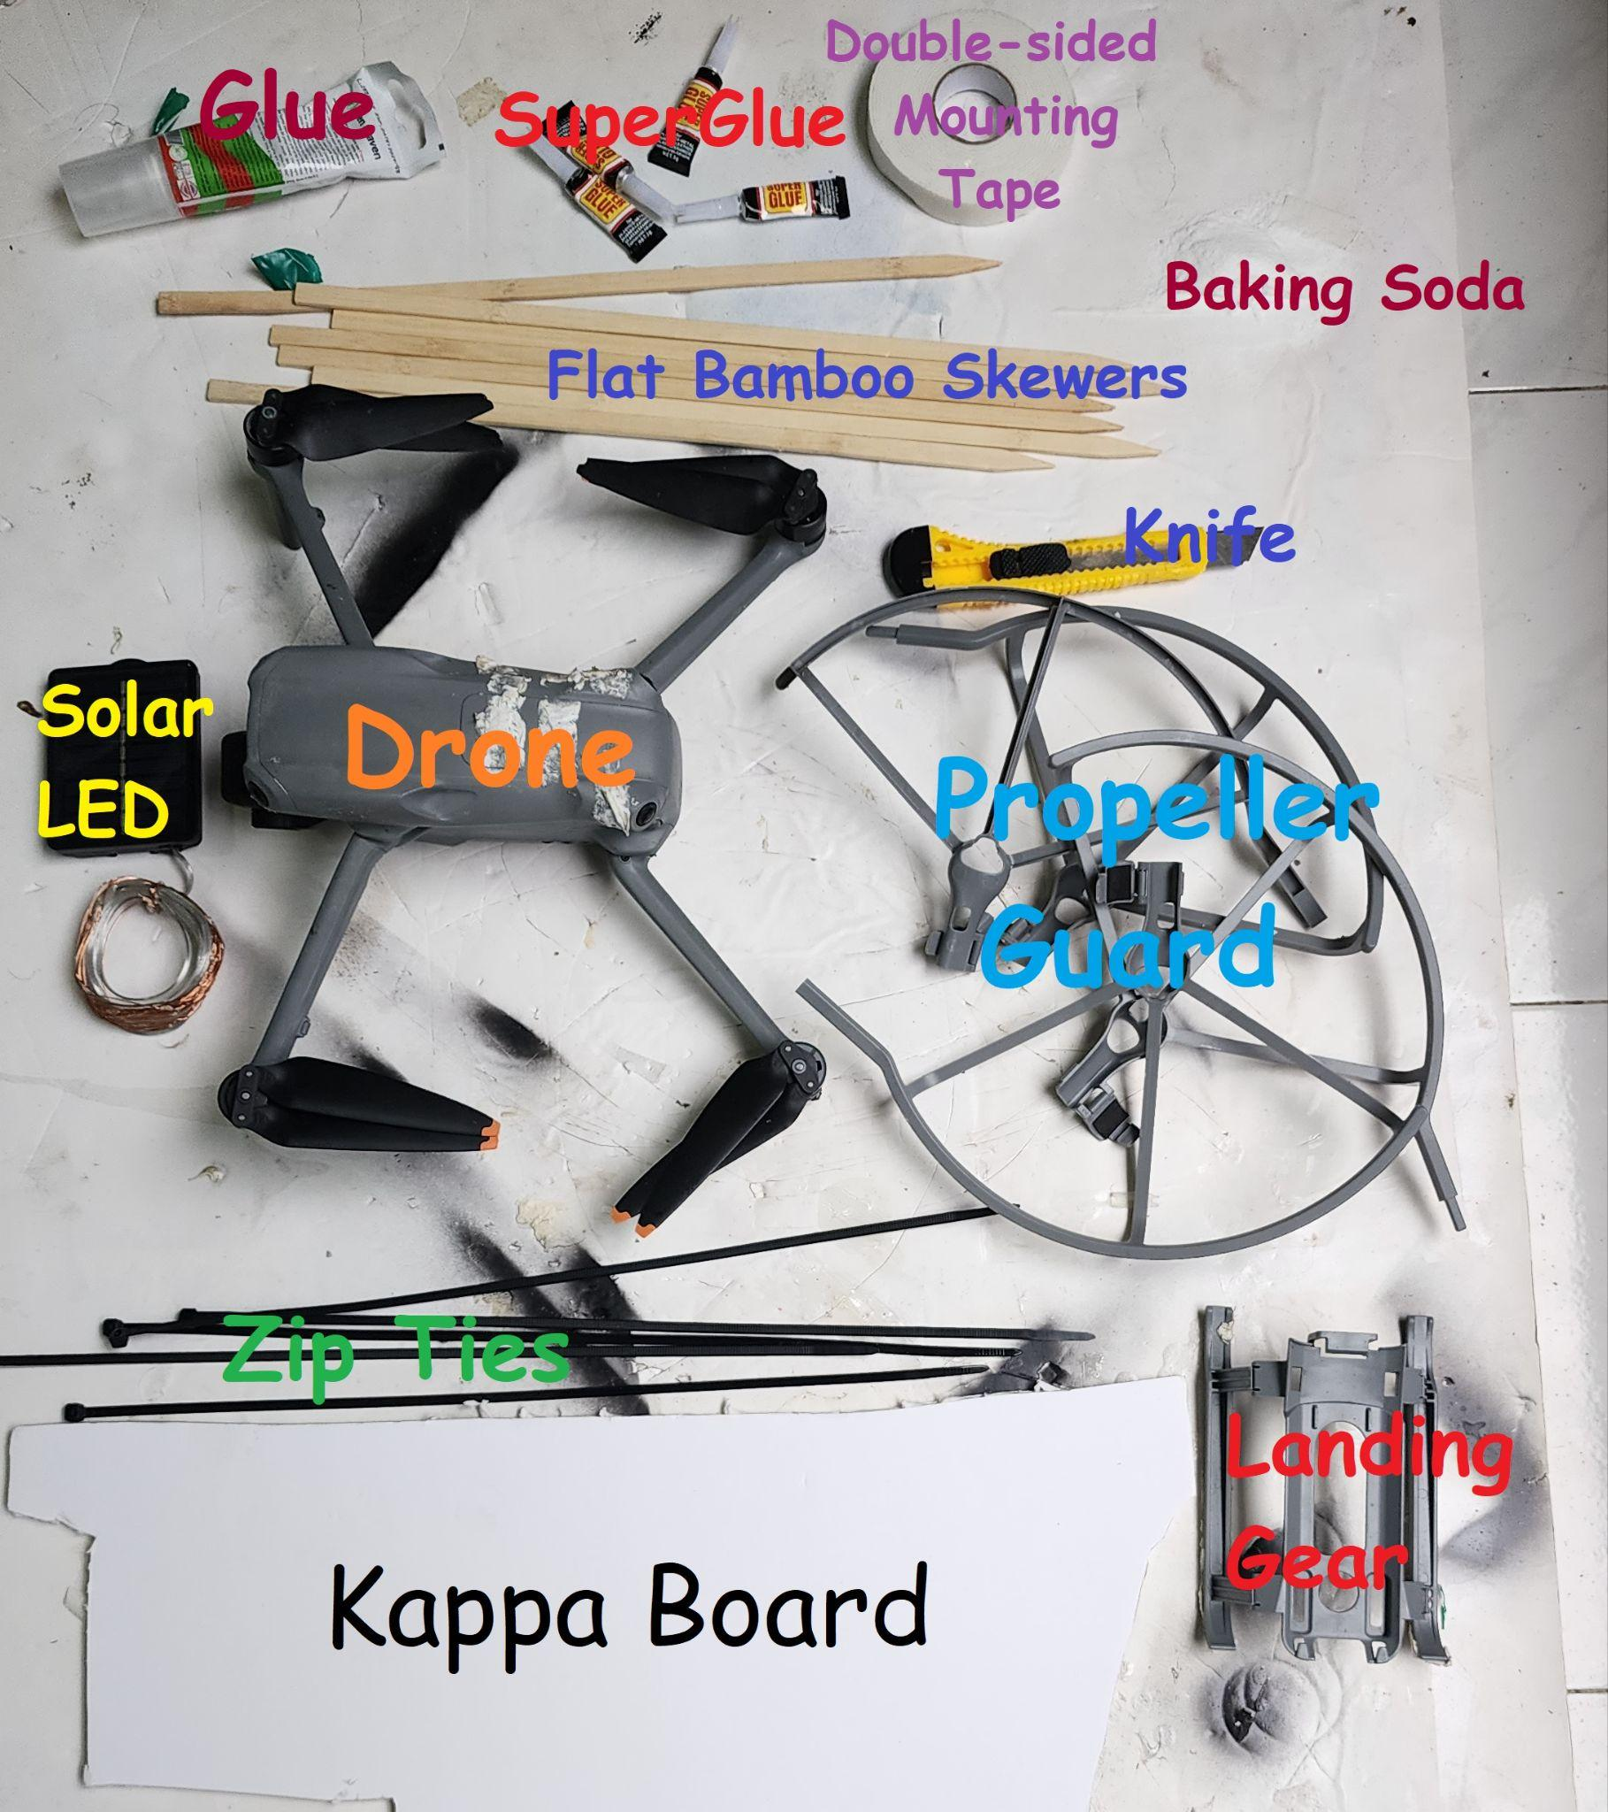

Equipment
Drone: I used DJI AIR 3 and AIR 2, AIR 3 can handle more weight and is more stable (150-300gr of payload).
Propeller guards: are essential when flying next to walls, minimal guards that only protect the side of the propeller and not the top are preferable since they don't block air flow from above.
Landing gears: These are essential since this is where the hooks will be attached and the plate will be hung.
Bamboo skewers: Sticks of the flat long type were used to create the hooks (around 40 cm) usually used for barbeque.
ZIP TIES: plastic type used to secure components to the drone.
Double-sided tape, thick type: This can be found in most art and office supply stores, is great for attaching the plate to nearly any wall surface, and is also used to secure hooks to the drone. Avoid paper-thin types, they don't stick to many surfaces.
Super Glue and baking soda: Where used for creating hooks and other components, the baking soda helps the superglue to solidify better and faster (optional).
Solar LED lights: Assuming this is what you want to hang. These come in many shapes and forms. Some can be quite heavy. For obvious reasons, you want to find the most lightweight as possible. I attached a link to where I got mine. They weigh about 60 grams (7x9 cm) and easily last all night even after 4 months of being hanged outside in the sun and rain.
https://www.aliexpress.com/item/1005004680109269.html?spm=a2g0o.order_list.order_list_main.35.598c18021XkU2U
Kappa Board: For attaching the device to the wall we need a flat rigid plate that is also lightweight and can withstand the elements, this can be found in most art supply stores.
Glue (optional): while the double side tape is responsible for sticking the plate to the wall in the short term, it is also possible to add some glue to make the attachment more durable (theoretically).

Drone preparation: Hooks

- First step: Make an L hook for holding the plate. The L hook used to hold the plate is made by simply creating a 90-degree bend in the bamboo skewer sticks into an L shape and using several layers of superglue and baking soda to harden the bending point (the baking soda used to harden). L shape of 10cm/30cm works nicely for DJI Air 3 drones. Create 3 pieces, two will be used for the hooks and one will be used as a kind of antenna to protect the top of the drone.
- Next, we attach two L hooks to the landing gear. The hooks should be pointed backward so the payload will be at the back of the drone. This way it will not block the camera and also for some reason it makes the drone more stable. Use double-sided tape to first attach the hooks to the landing and then wrap PVC tape or duct tape around the connection. Having the L-bent joint 21 cm from the drone body works nicely for AIR 3.
.
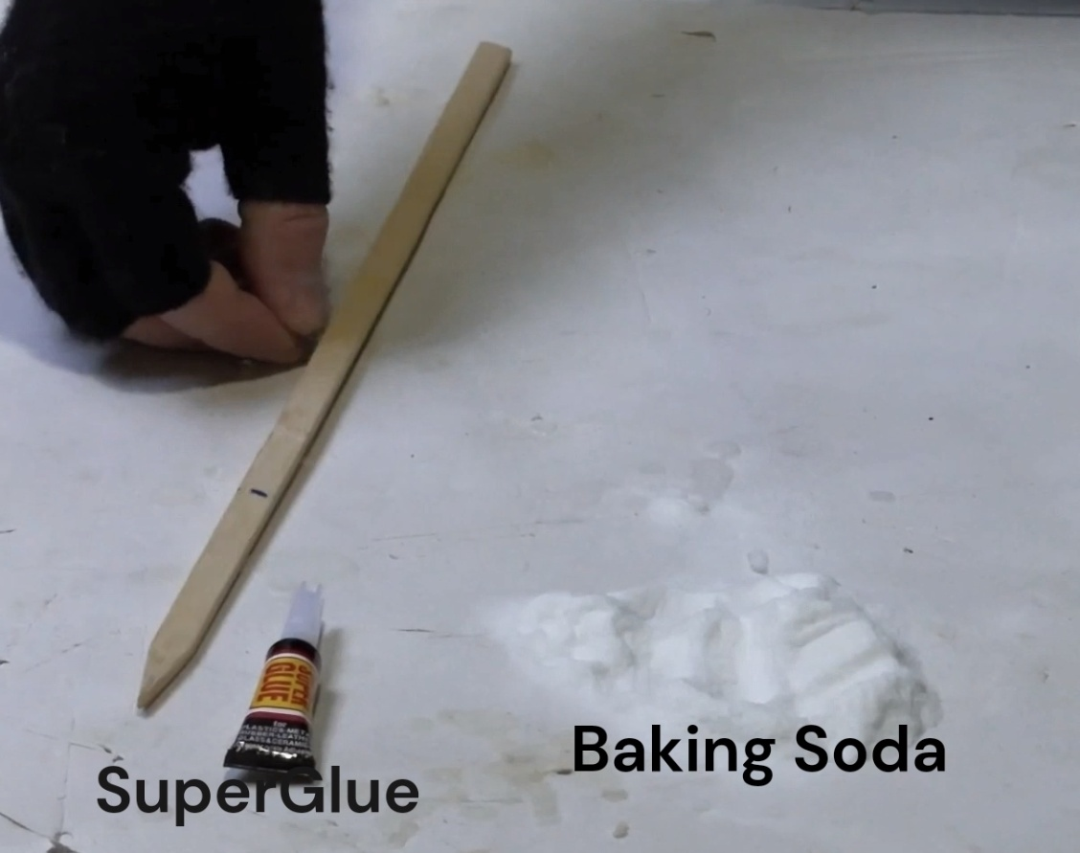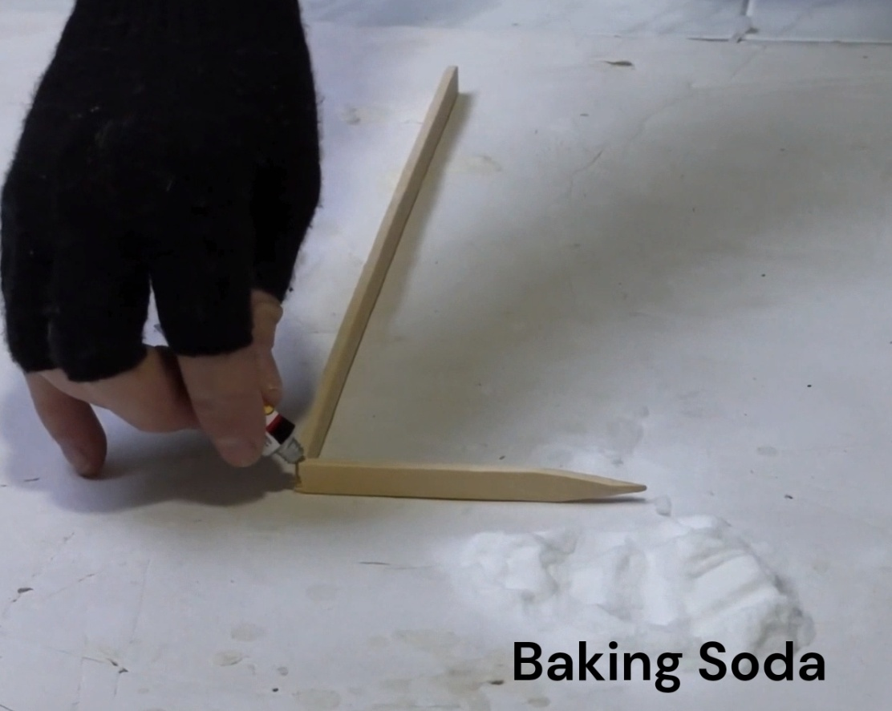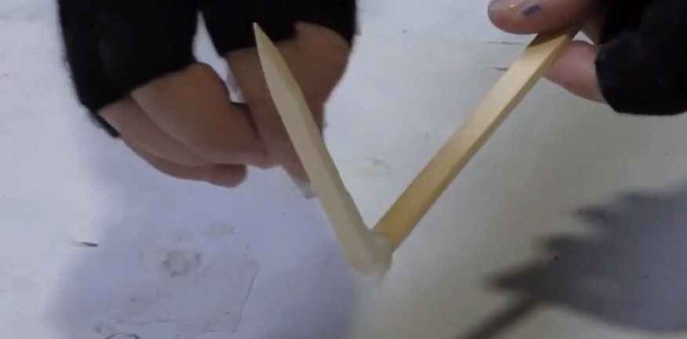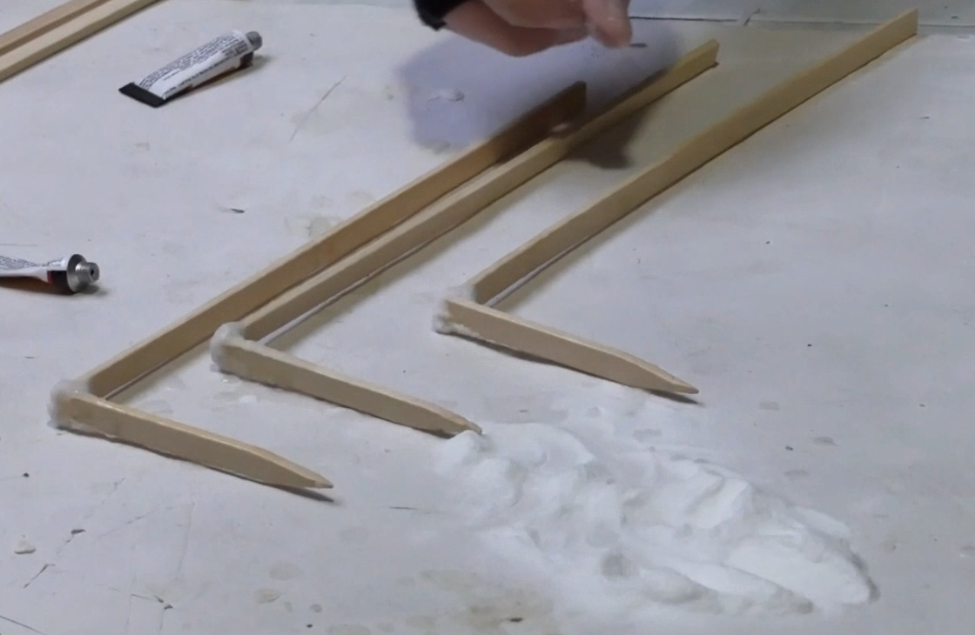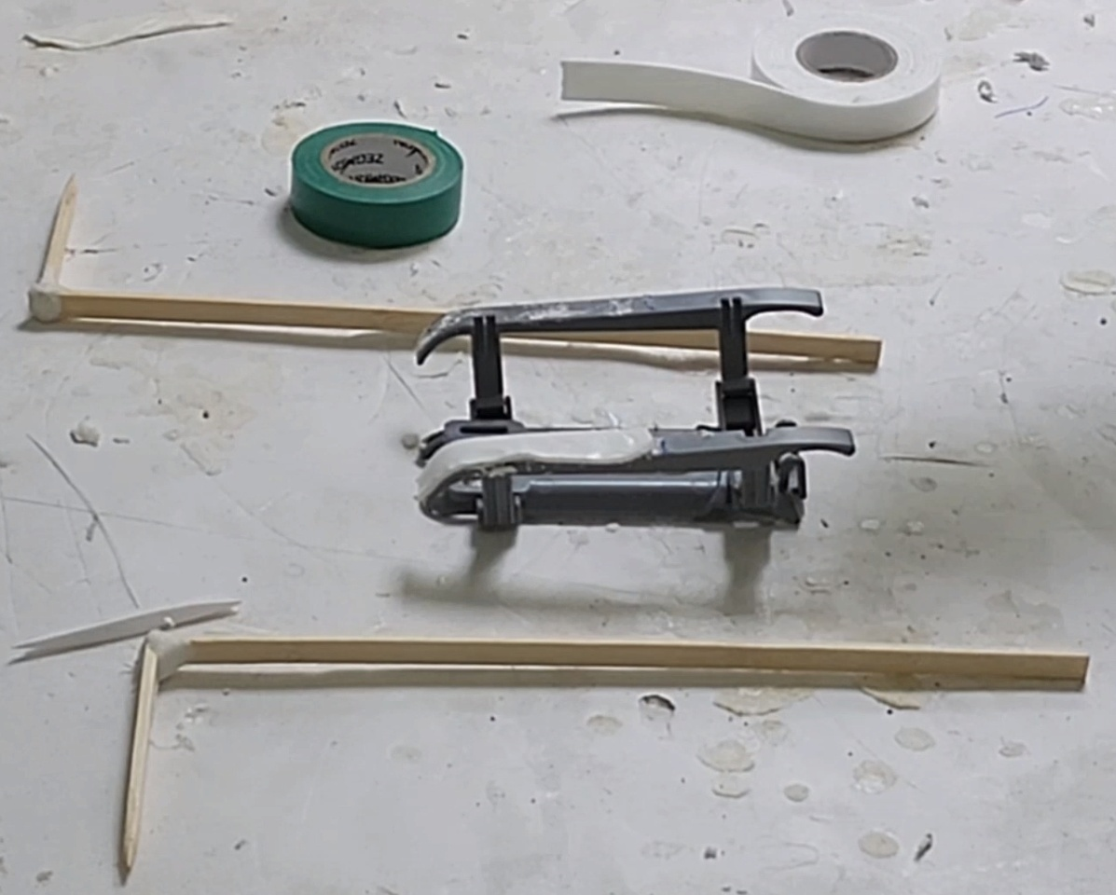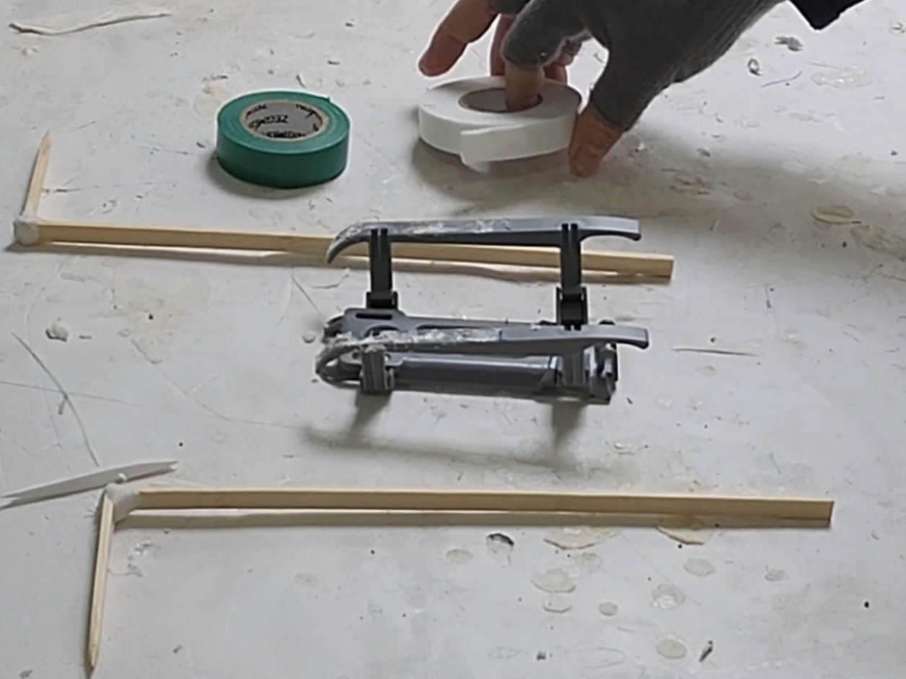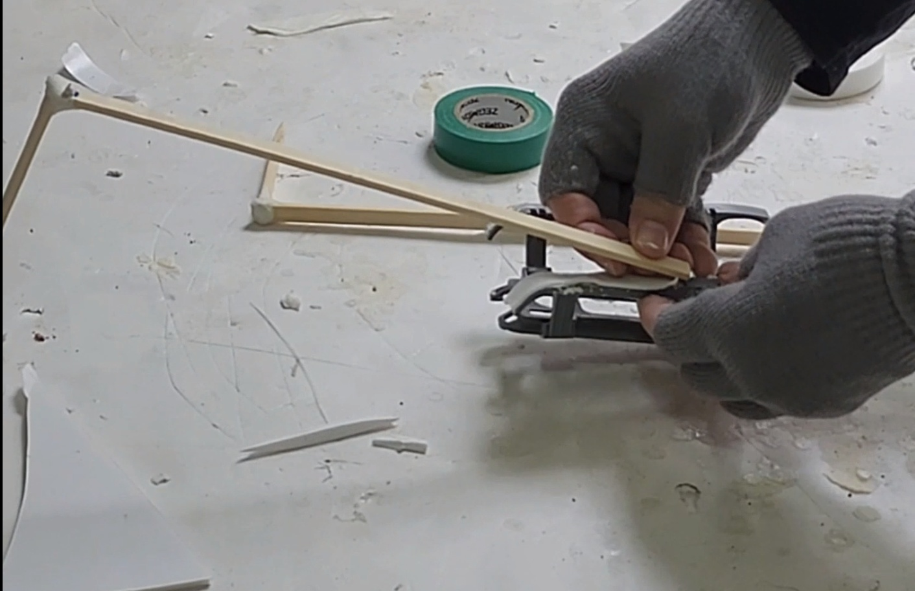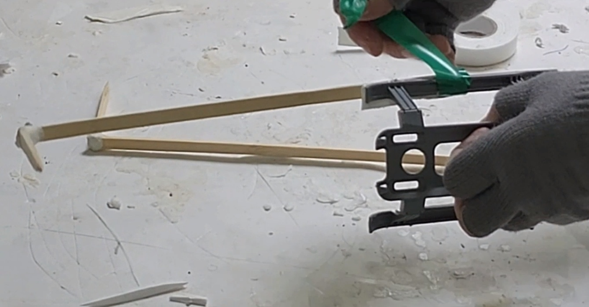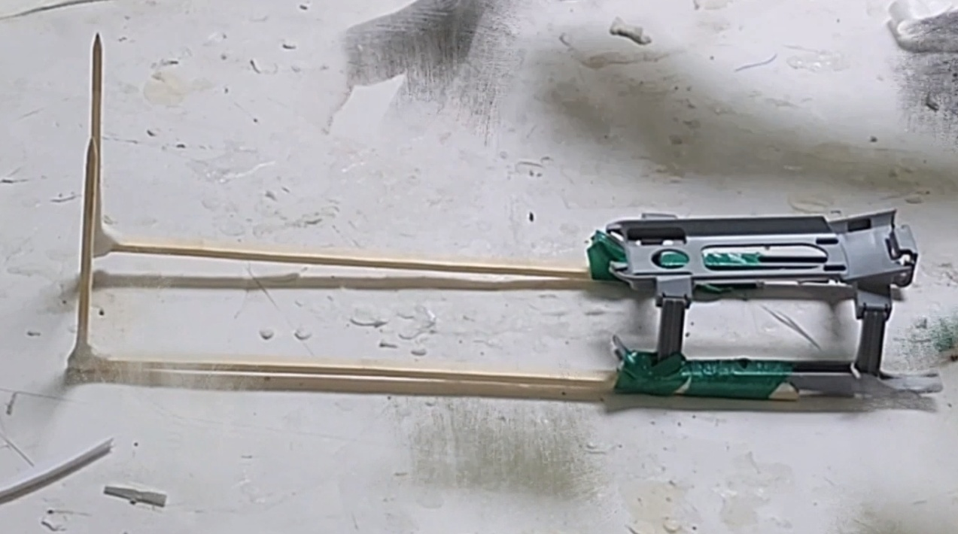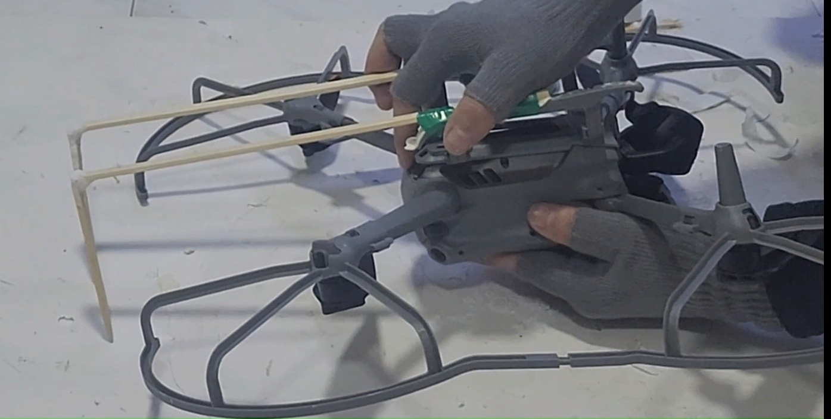

Drone Hooks Floor/Pusher
Just hanging the solar cell plate on the L hook will leave it too loose, therefore there is a need for another component, which is a little hard to explain. It's a small flat plate shaped like “(“ that will be stuck on the bottom of the hooks. This will prevent the plate from sliding down. Also, it will push the plate and help it to hang more rigidly on the drone and not swing loosely in a way that destabilizes the drone. Best look at the video for understanding this part. Having two pieces of kappa board one on top of the other connected in duct tape gives good results. (20 x 5 cm size works nicely for AIR 3
)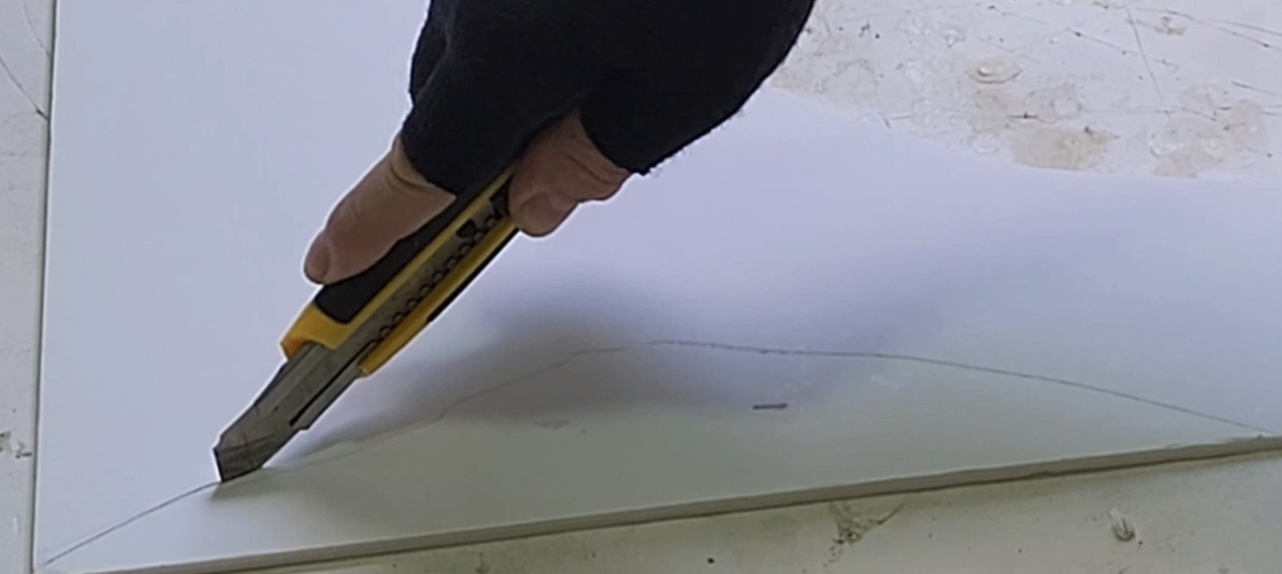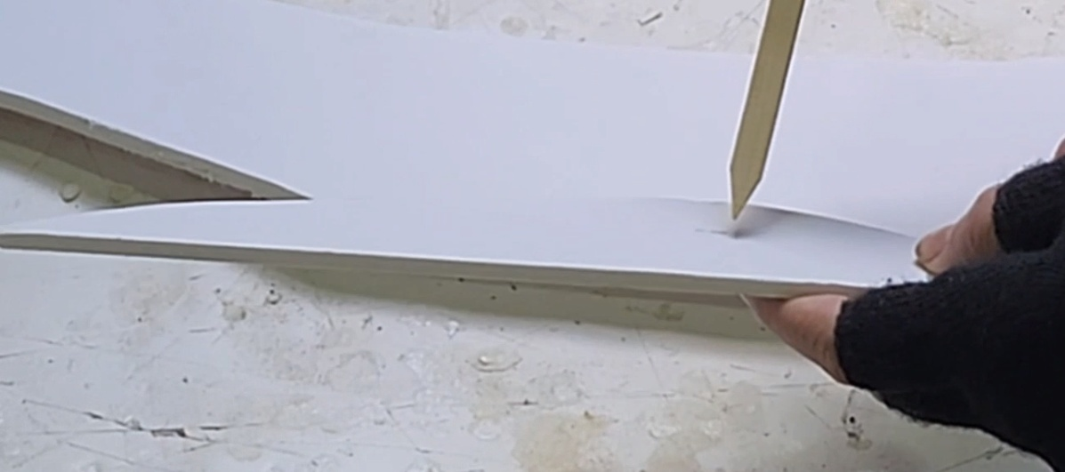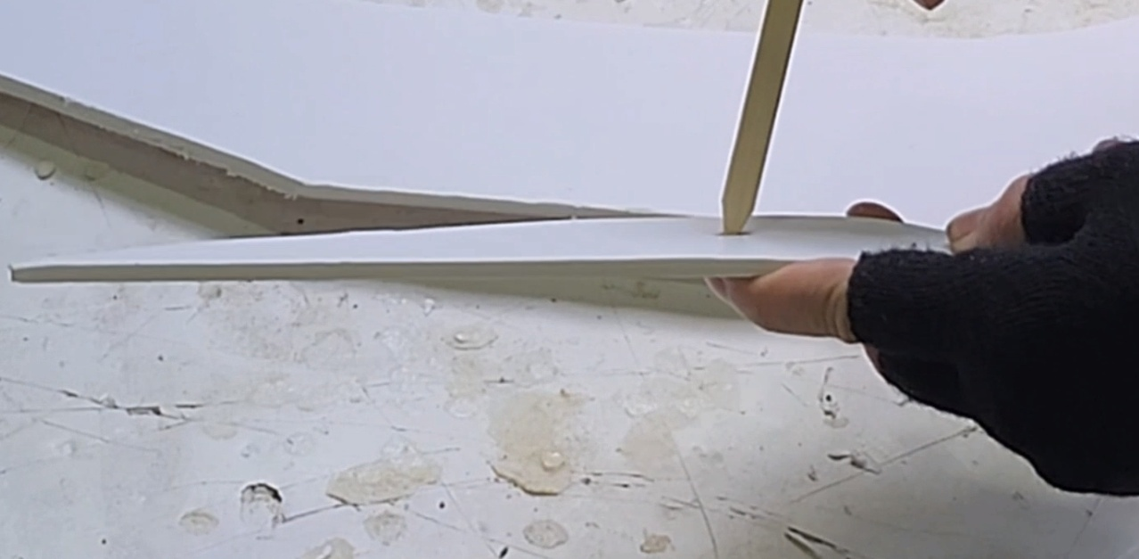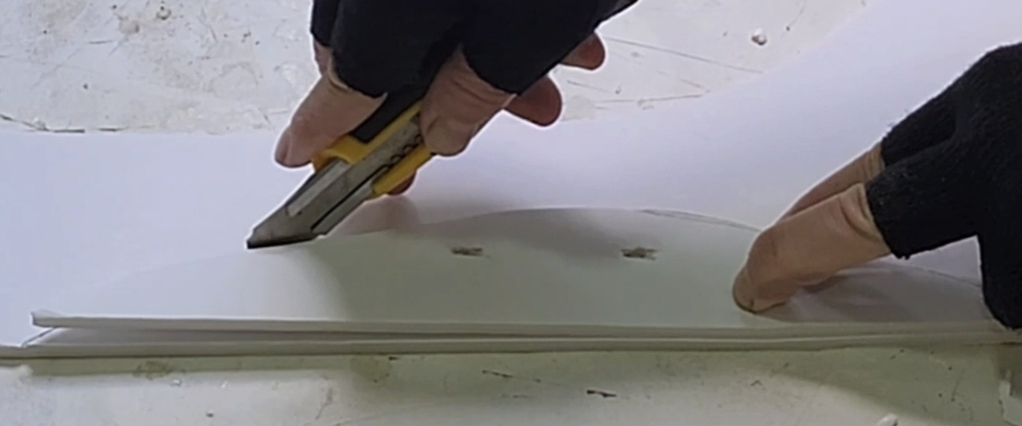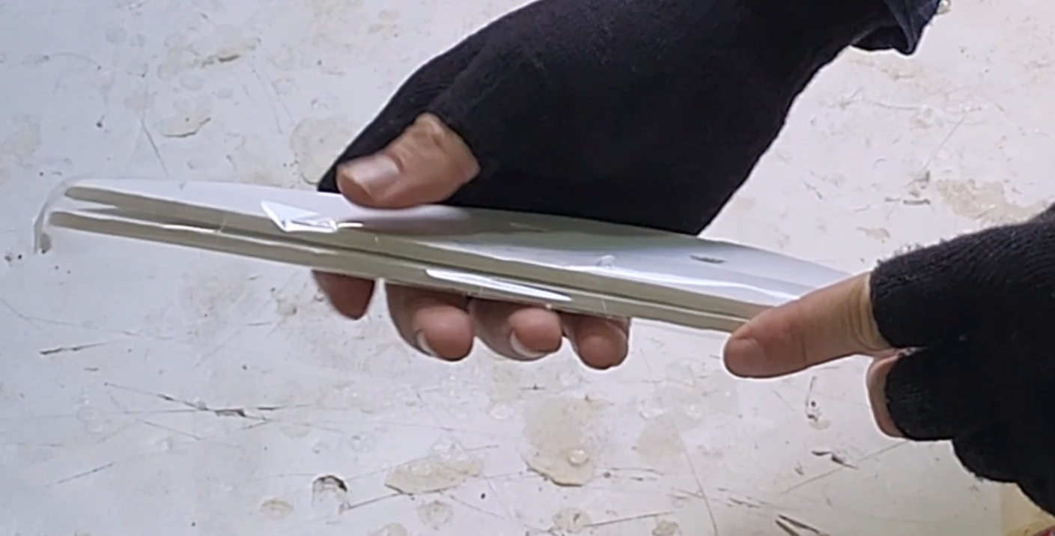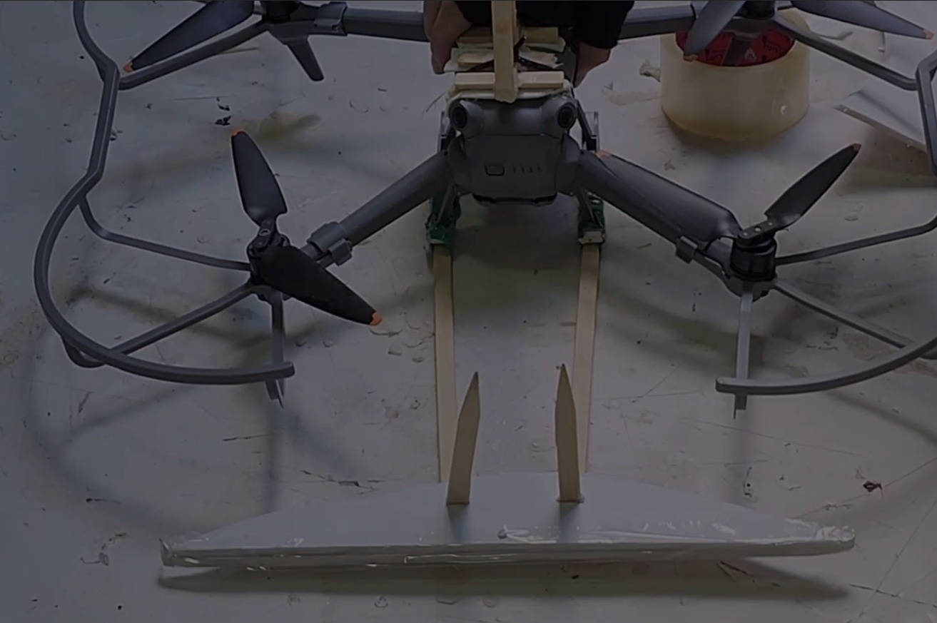

Drone Preparation: Top stick/antenna.
When the drone pushes the plate to the wall there is real danger for the drone to get sucked to the wall. This happens partly because the drone sucks the air from above creating low pressure between it and the top of the wall. Also, the drone is tilted when it pushes the plate to the wall. This can cause the drone to flip vertically get suck to the wall and crash. To avoid this we add a vertical stick (kind of like the antenna) that prevents the drone from getting tilted to the wall. The L hooks we created earlier work nicely for this but need a few modifications. First, the joint might not be strong enough so it recommended adding another beam to create a triangle. Again this can be done with bamboo skewer sticks + superglue for the joints. To attach the stick stable way to the top of the top of the drone you need to add some kind of a wide base. This can be done by adding three cross beams to the short side of the L stick (the long side will be the antenna). Again this can be done using bamboo skewer sticks and superglue. This can be attached to the drone using double sided tape
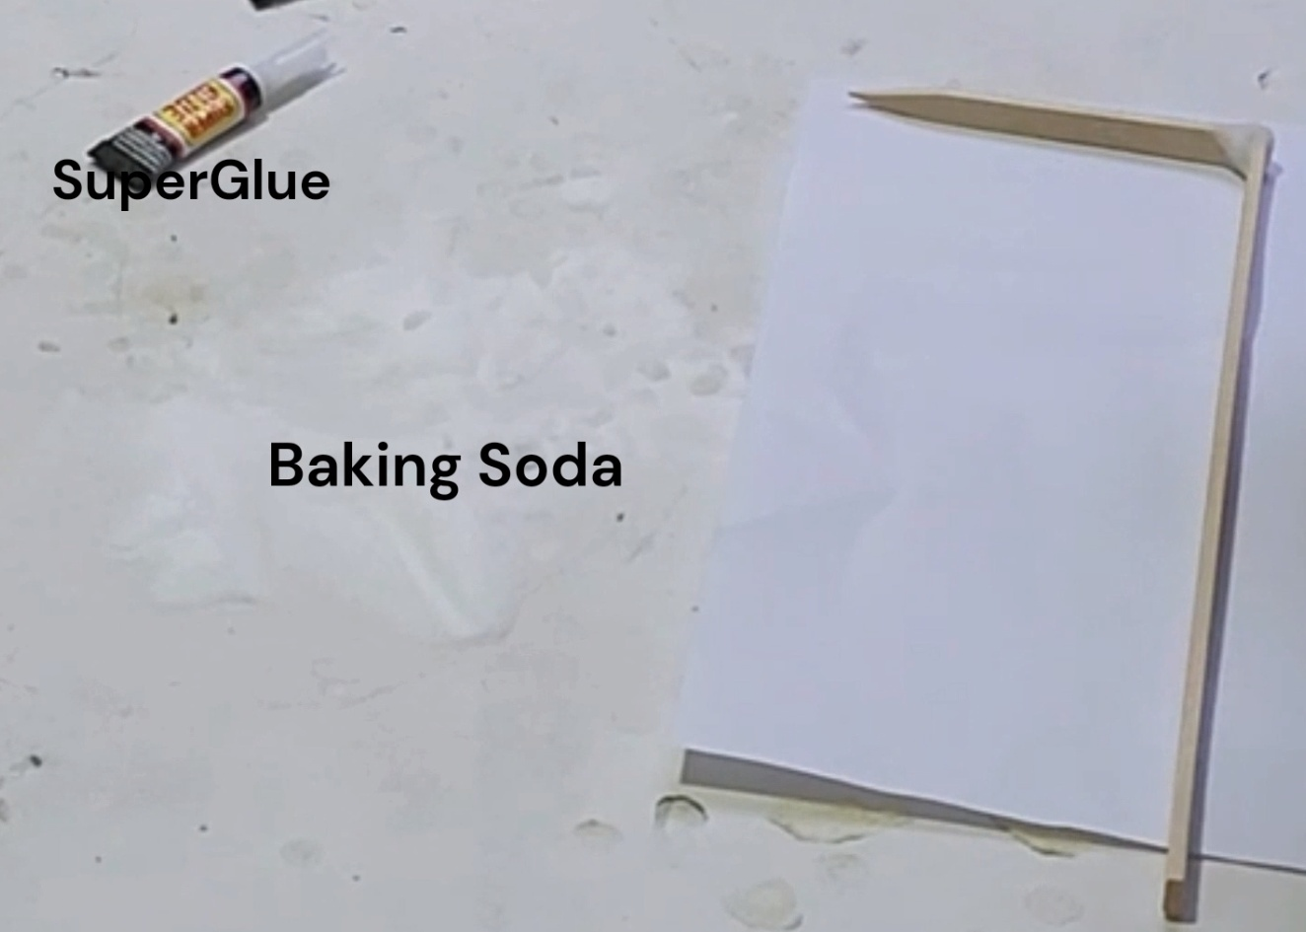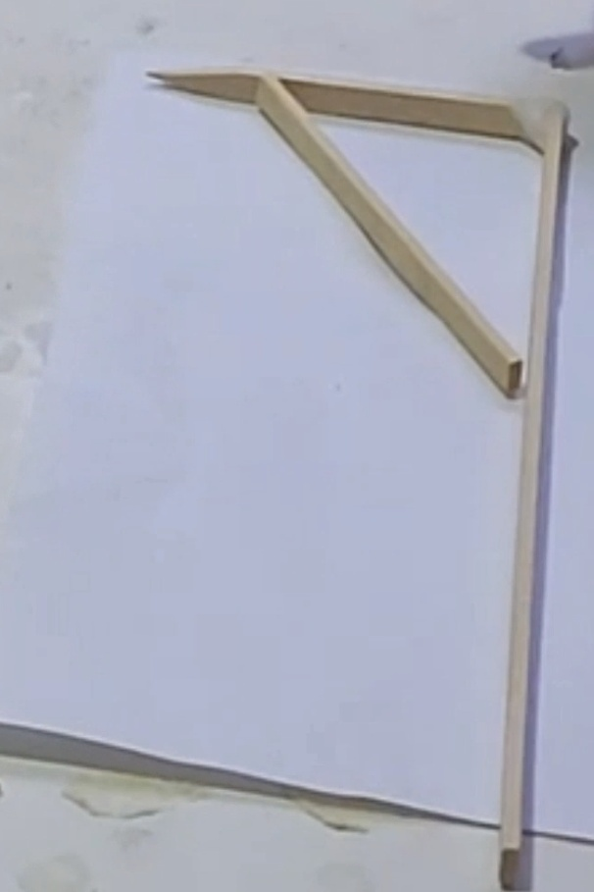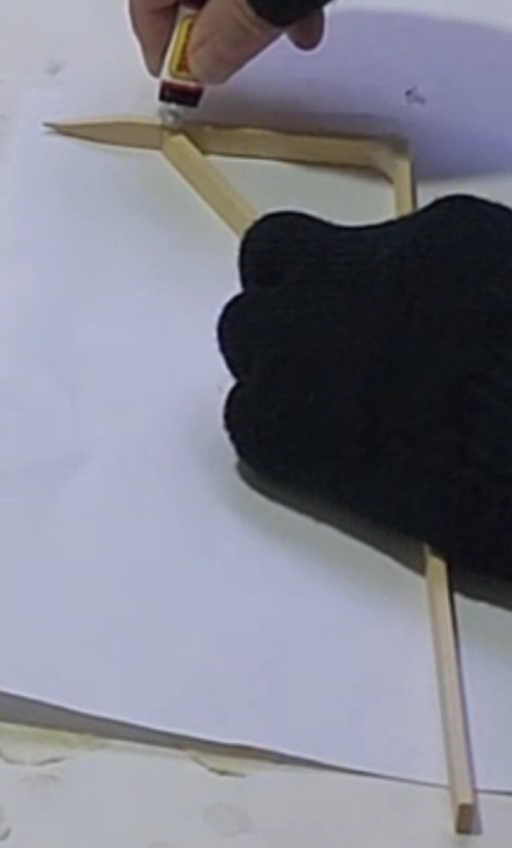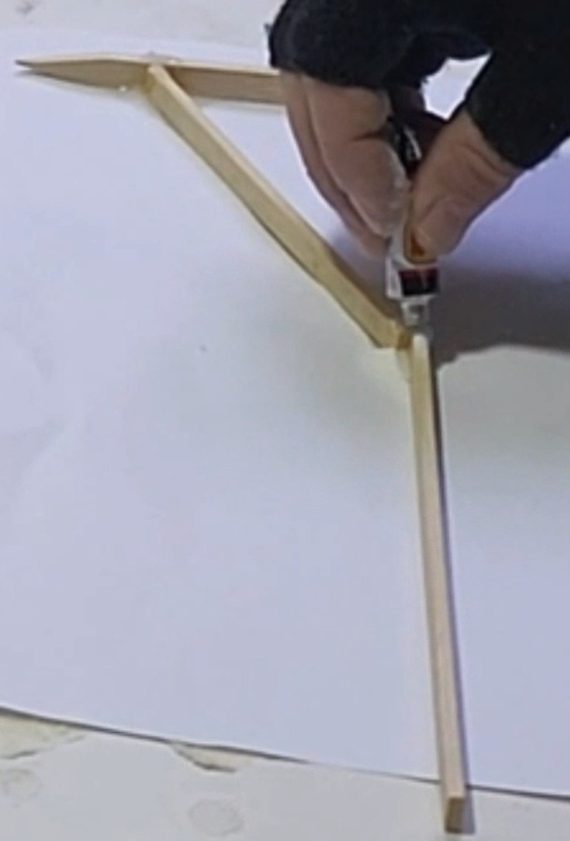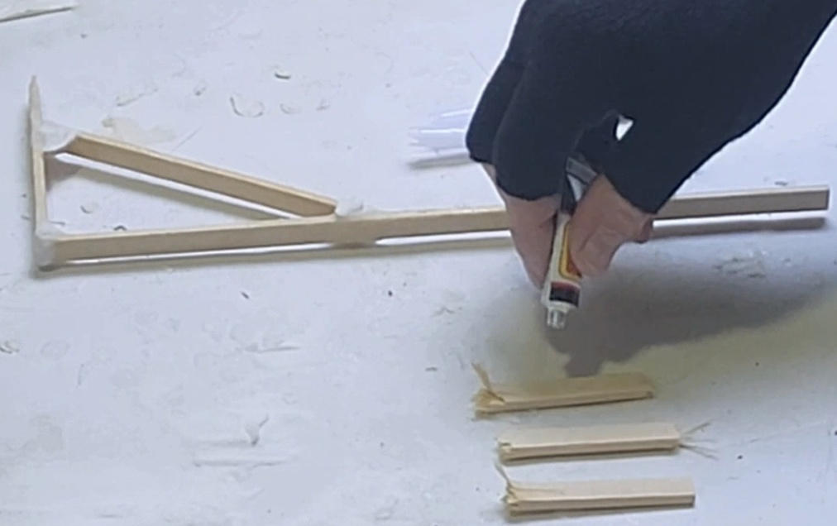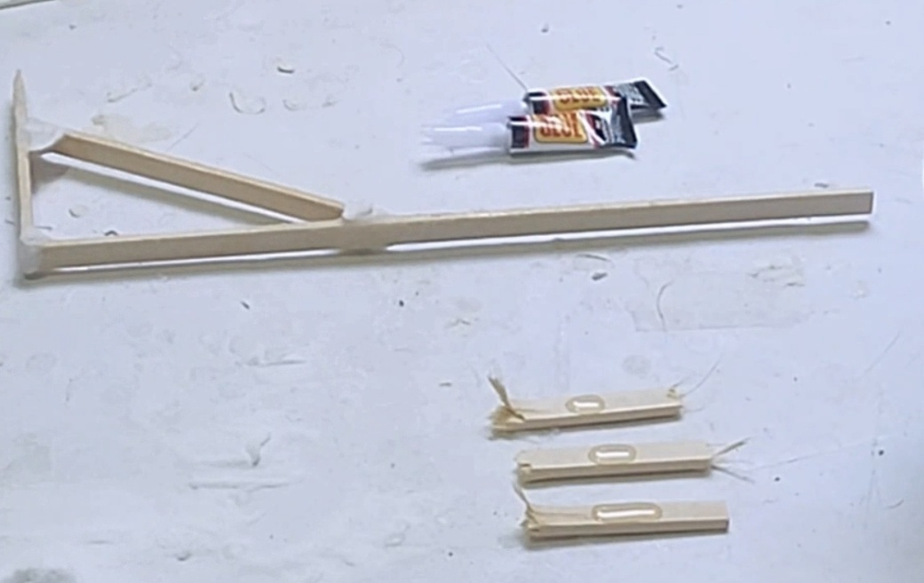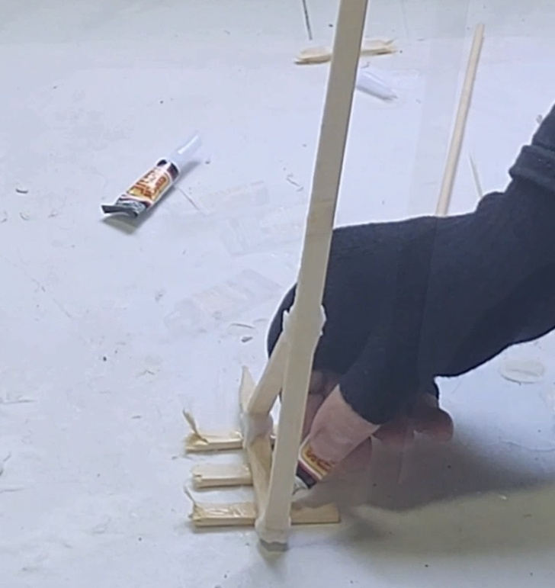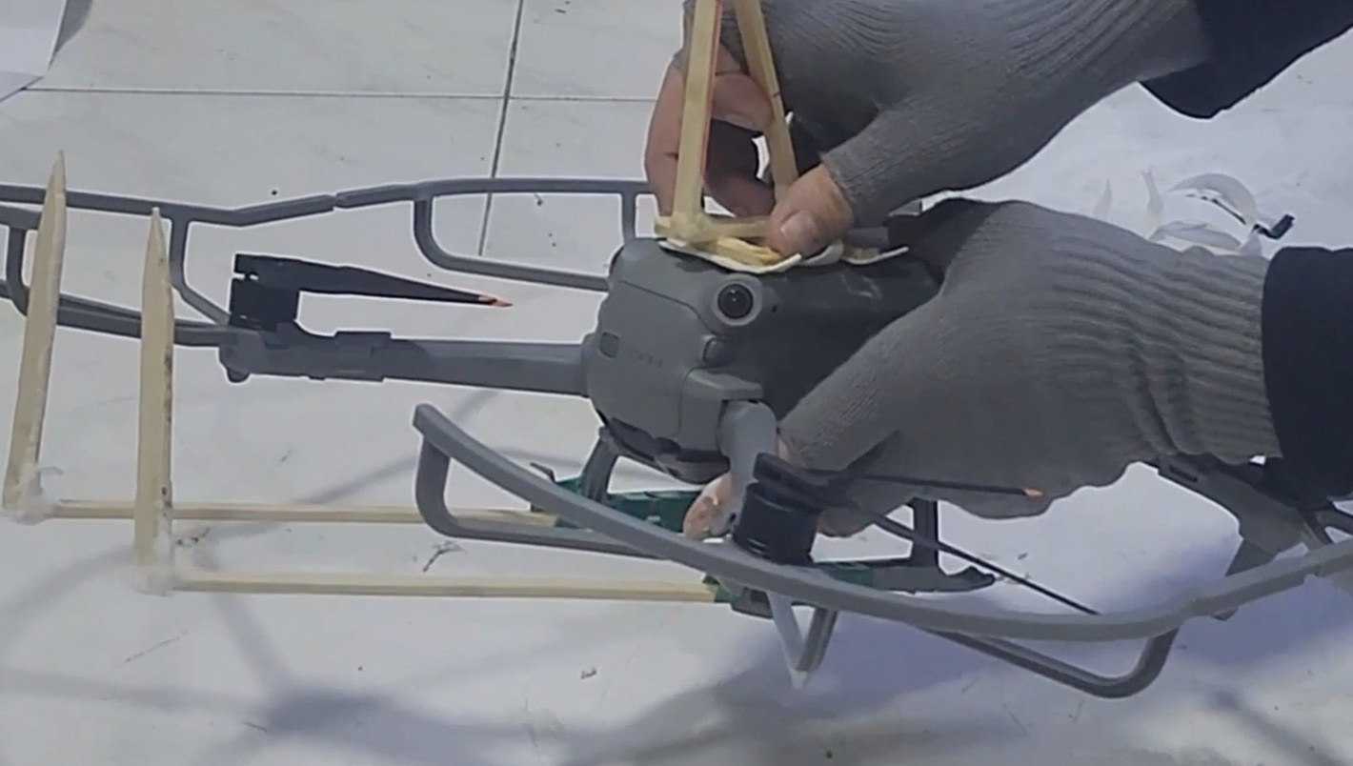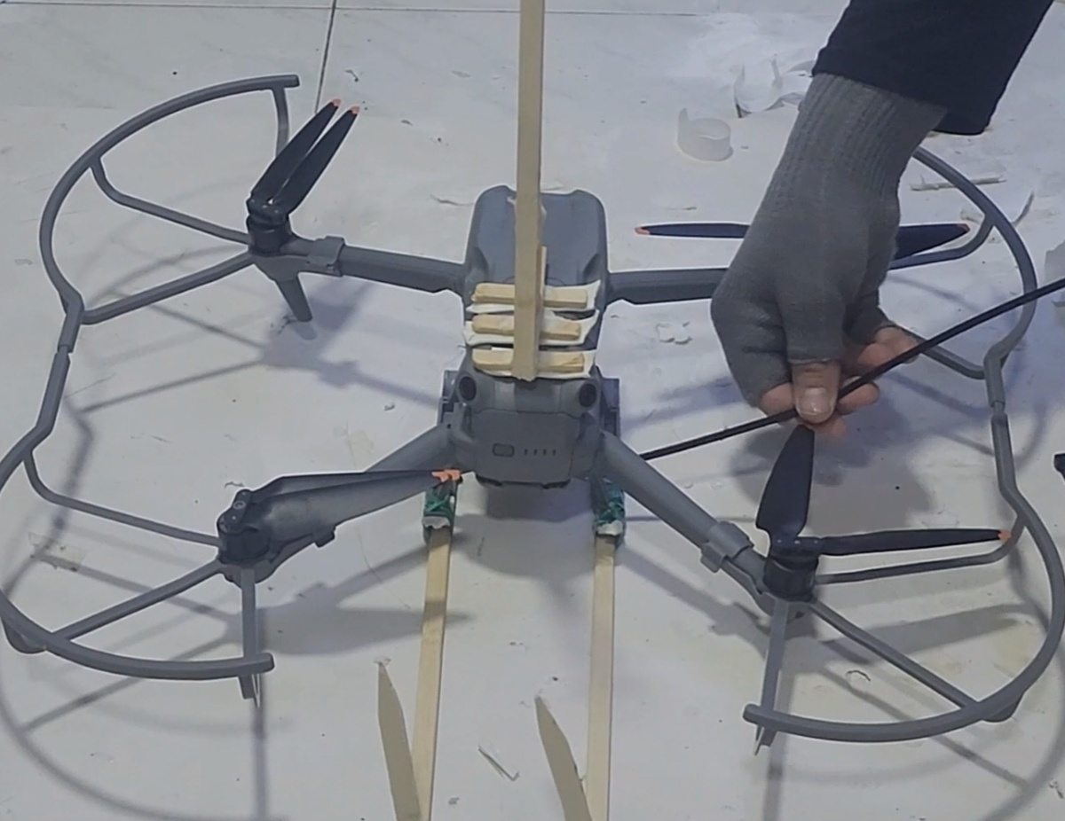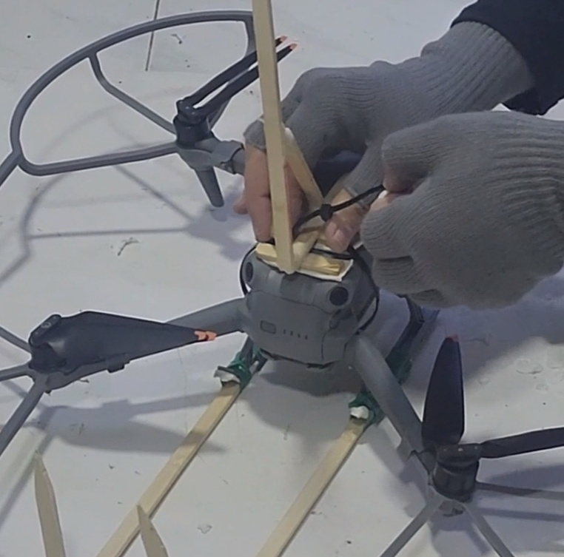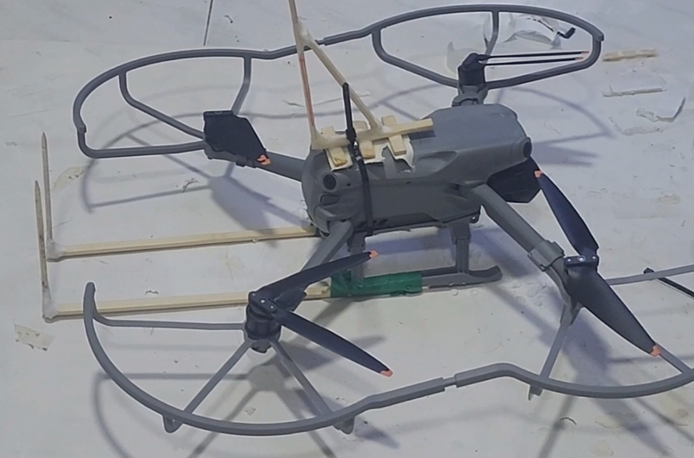

Final drone preparation
Once all components are ready they should be attached to the drone, including propeller guard landing gear and antenna stick. The landing gear and antenna should be secure to the drone with two zip ties. Note however that the bottom of the drone often contains some sensors, make sure the zip ties do not block these sensors.

Plate and Solar-powered LED preparation
The plate is what will hold the solar LED (or other device) to the wall.
It needs to be a rigid flat and lightweight, kappa board sold in most art stores to work nicely. An area of 22X16 CM is enough for good pasting for most surfaces. Smaller surface and it might not stick well, but too large will make it harder for the drone to carry.
- The Solar Panel can be attached to the center of the plate using glue. Note that the buttons that control the LED lights are usually at the back of the solar cell so once it sticks you can't access them. Make sure to activate it before. To avoid cases in which the keys are accidentally pressed during hanging it is also recommended to cut a small hole in the board beyond the buttons and cover it with duct tape from the other side.
- Next is creating the loop that will be used to hang the plate on the drone. This can be done by using ZIP TIE and passing it through the board's bottom part. Around 5 cm below the cell. This creates the loop where the hook will enter. Note that you need to adjust the size of the loop to the size of the hook. The plate needs to be hung on the drone stiff enough in an almost vertical way so it will not swing freely or bend too much, and doesn't cover the propeller top and disturb airflow. But I also need to lose enough for the drone to slide out once the plate is attached to the wall. This part needs some playing around and adjustment.
- Adding double-sided tape: The final step is adding double-sided tape at the back of the plate in horizontal stripes. One stripe should cover the back of the ZIP-TIE. Using standard thick double-sided tape found in most art supply stores is good. Avoid paper-thin tape. The thickness significantly improves the hanging probability on rough surfaces. Adding two layers of tape on top of the others is recommended since it improves stickiness.

Dealing with wires:
When using Solar LED light string one thing to be considered is that the LED wire will hang below the plate and might get entangled with the drone when it descends. Passing the wire on the side of the plate so it will not go directly down but instead sideway and will avoid the drone is recommended and can prevent crashing.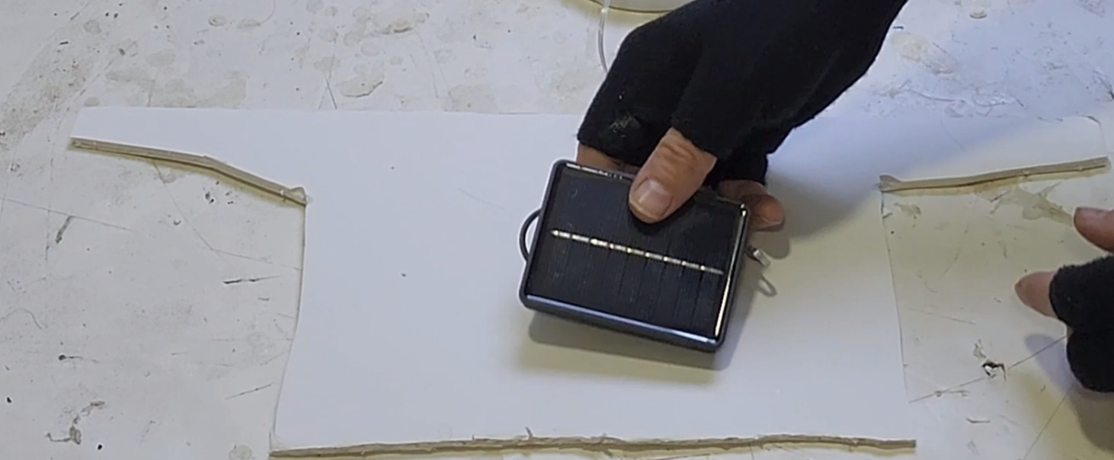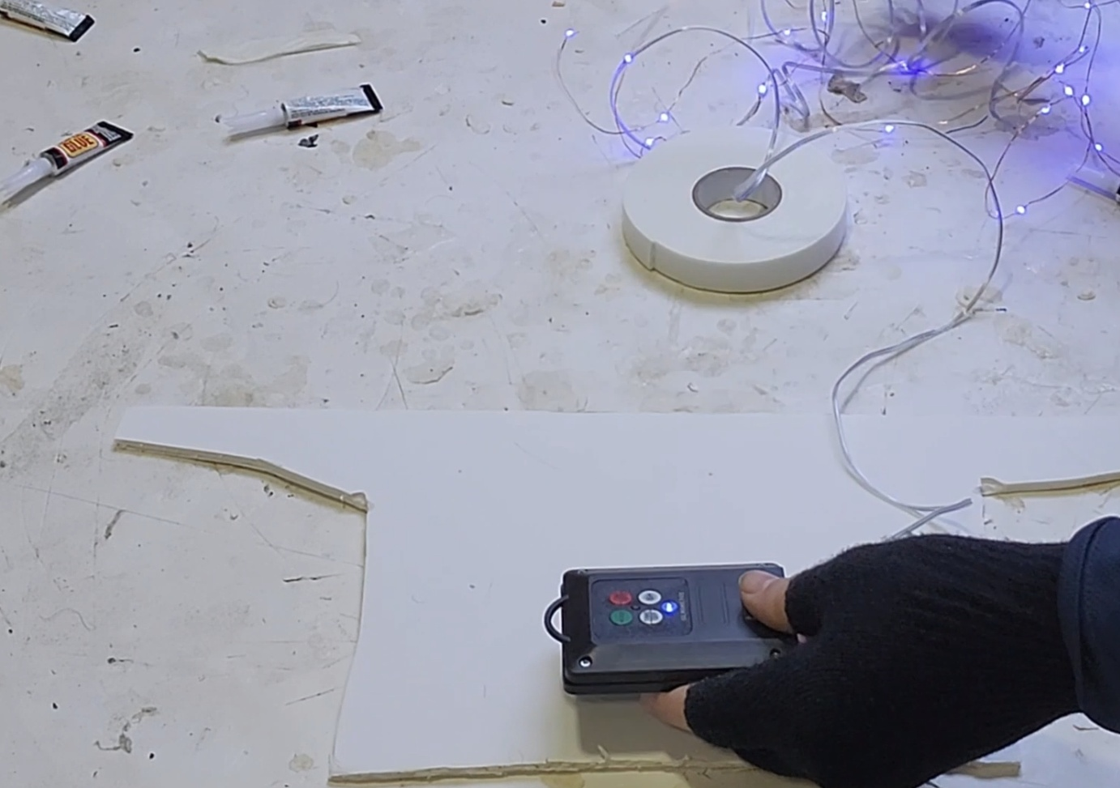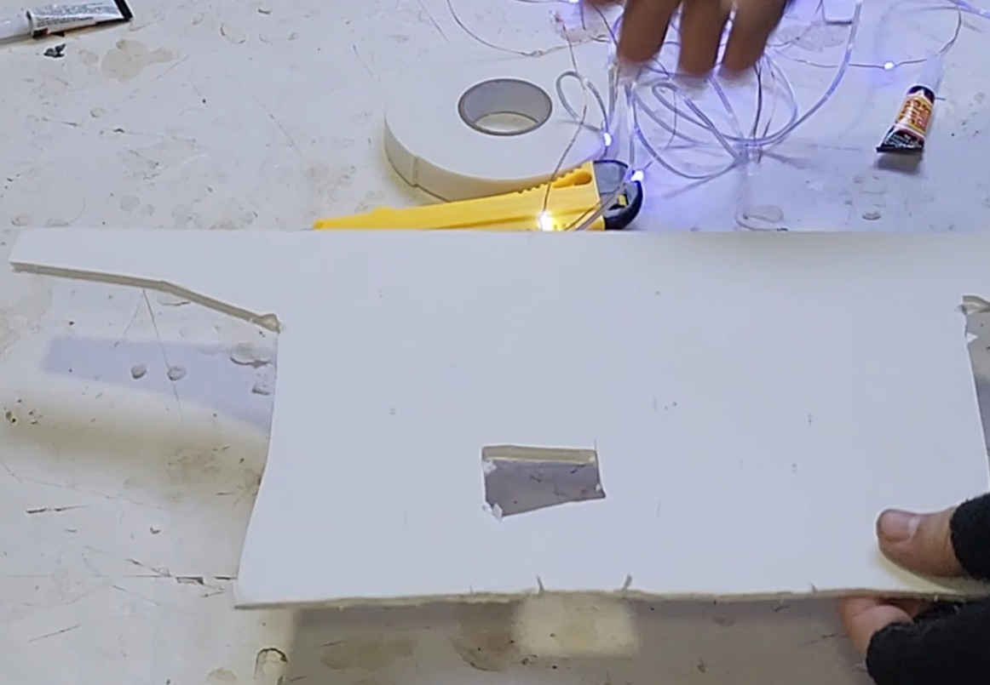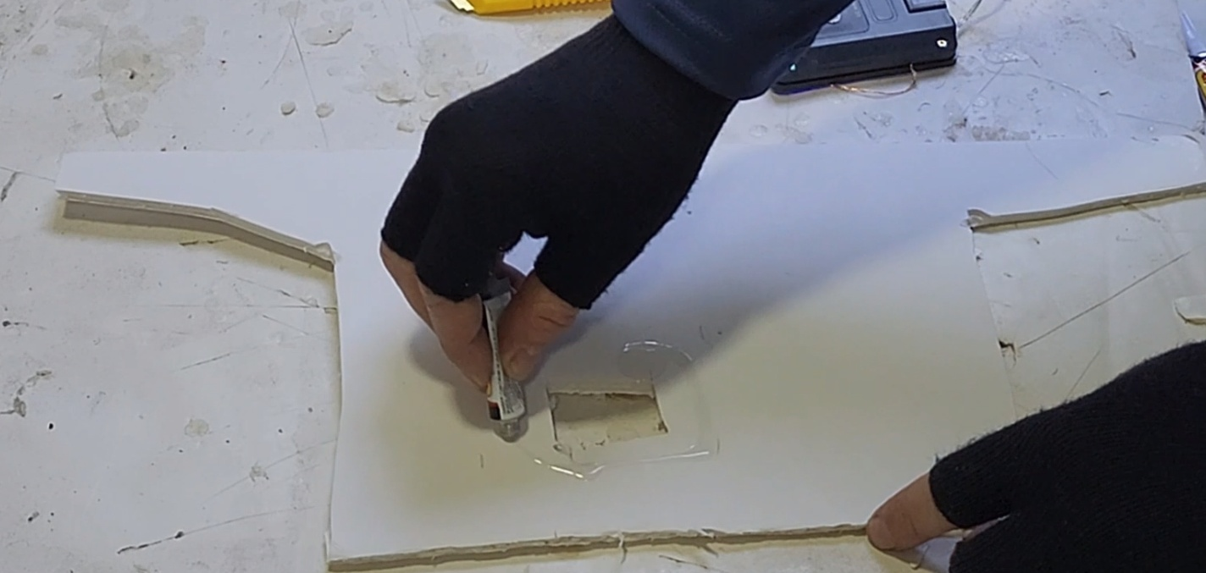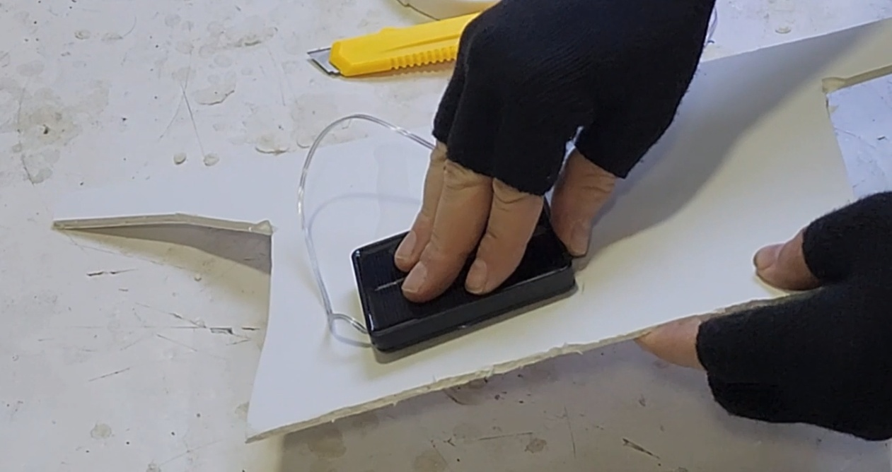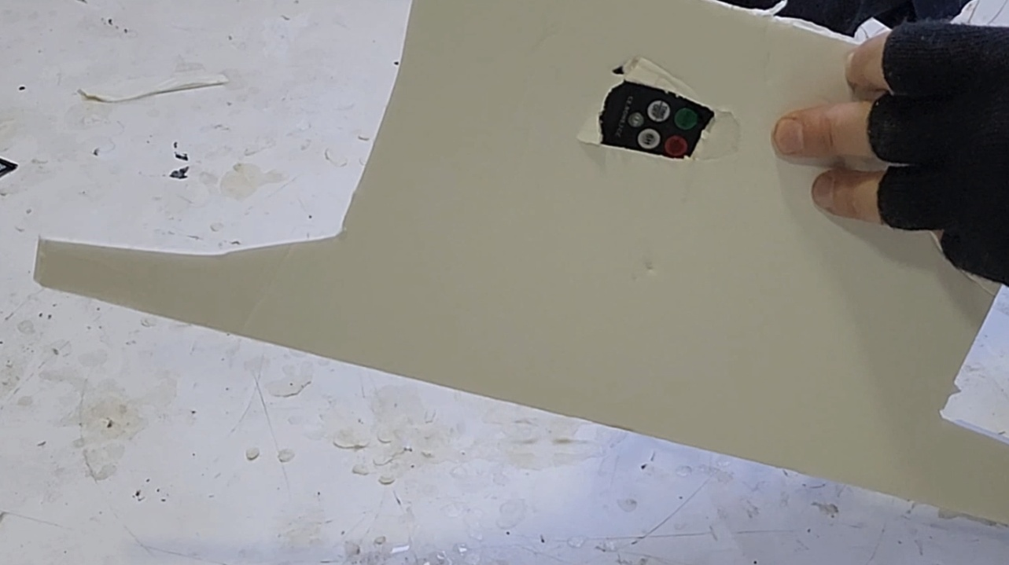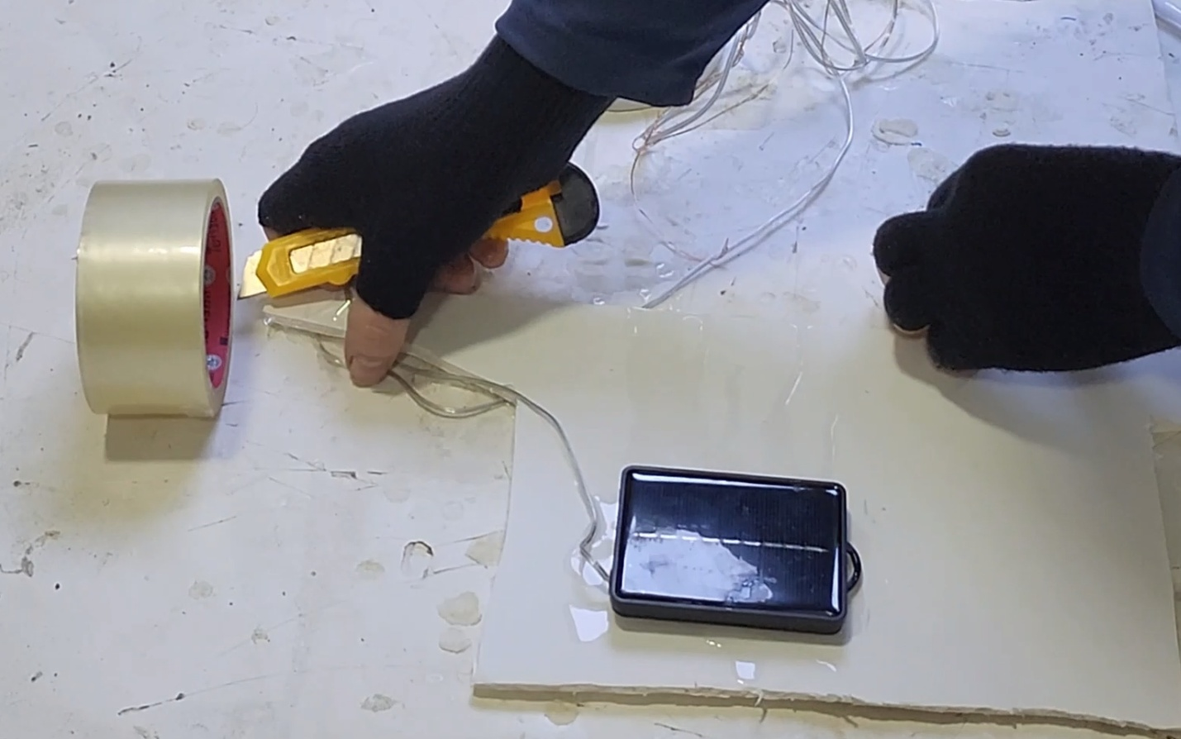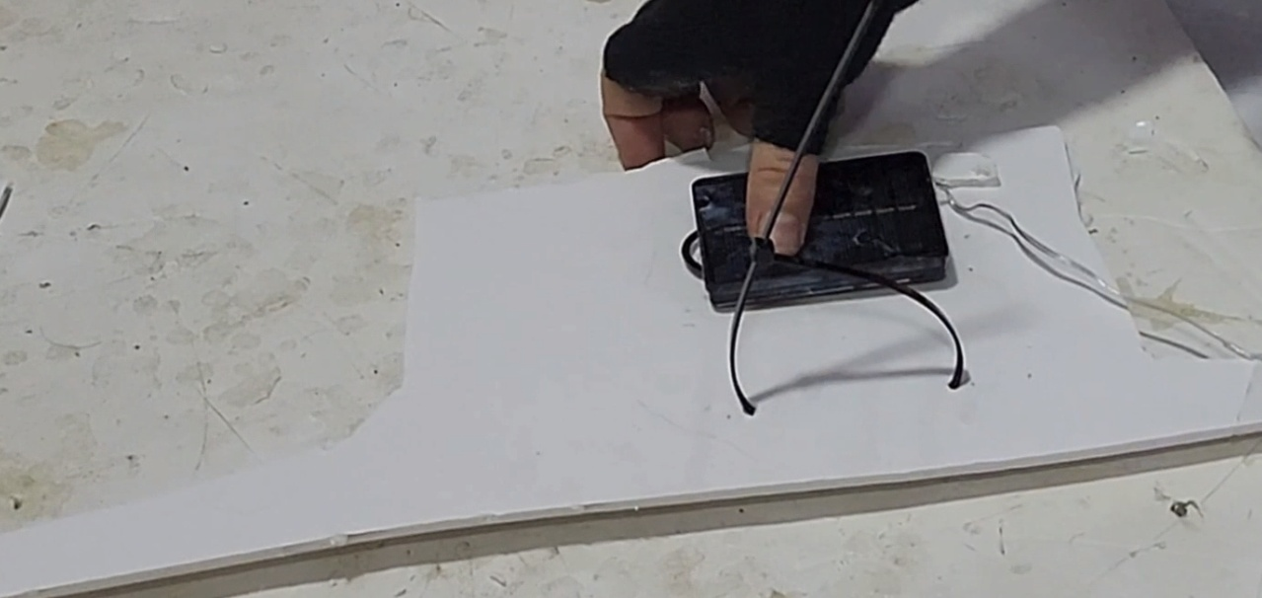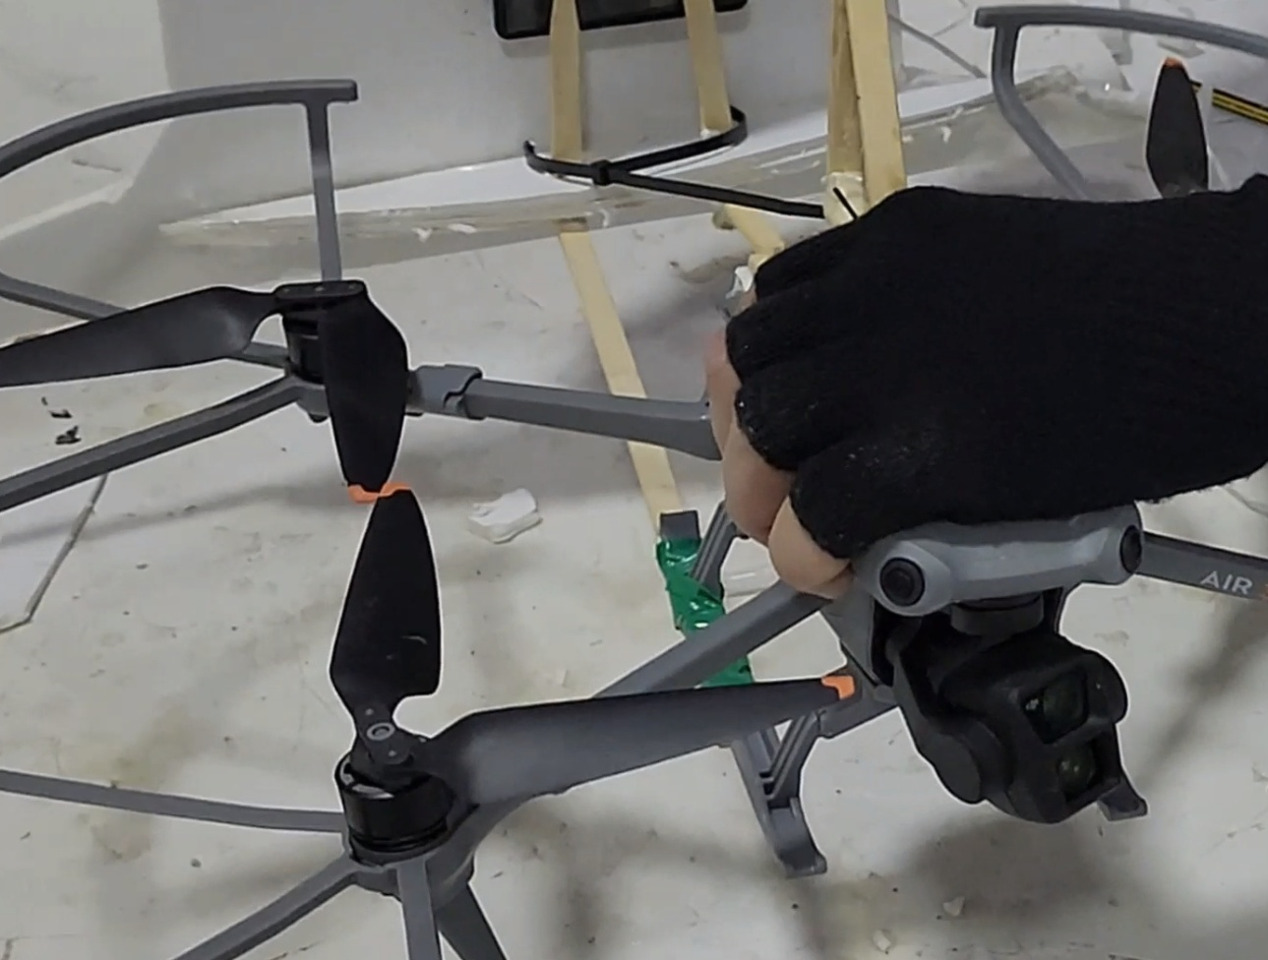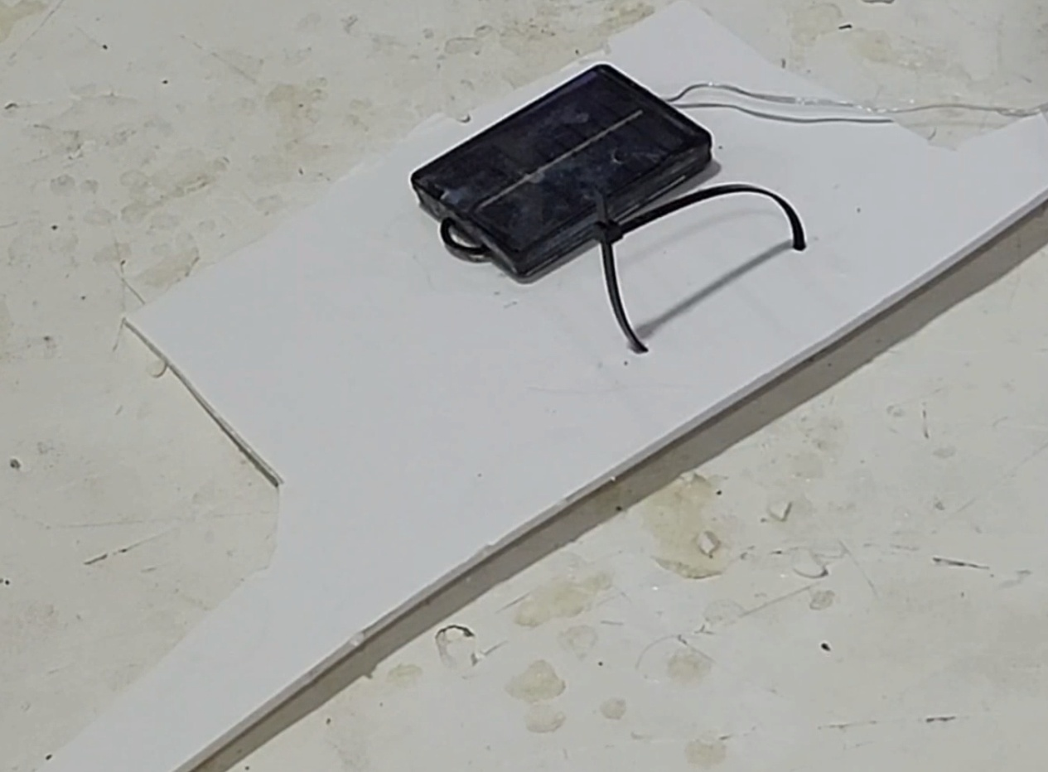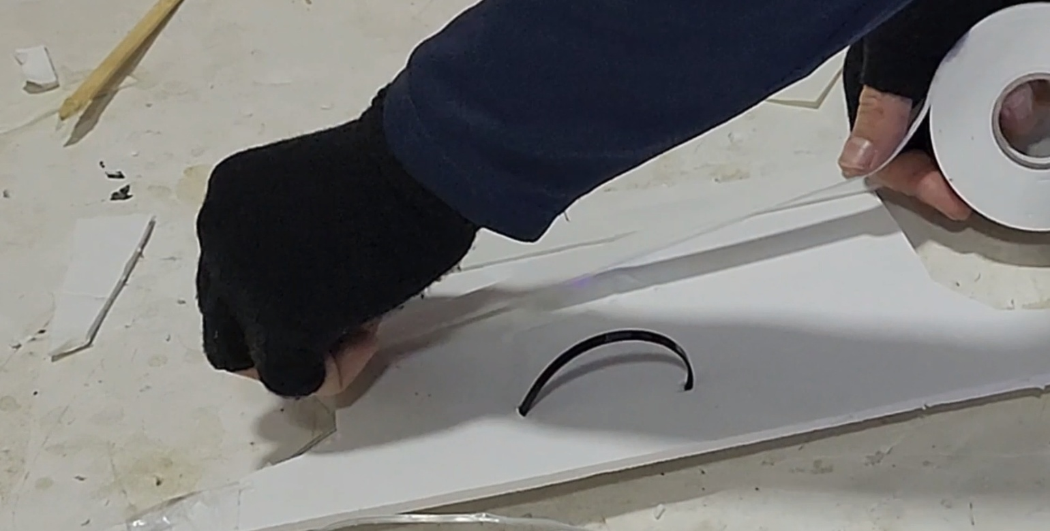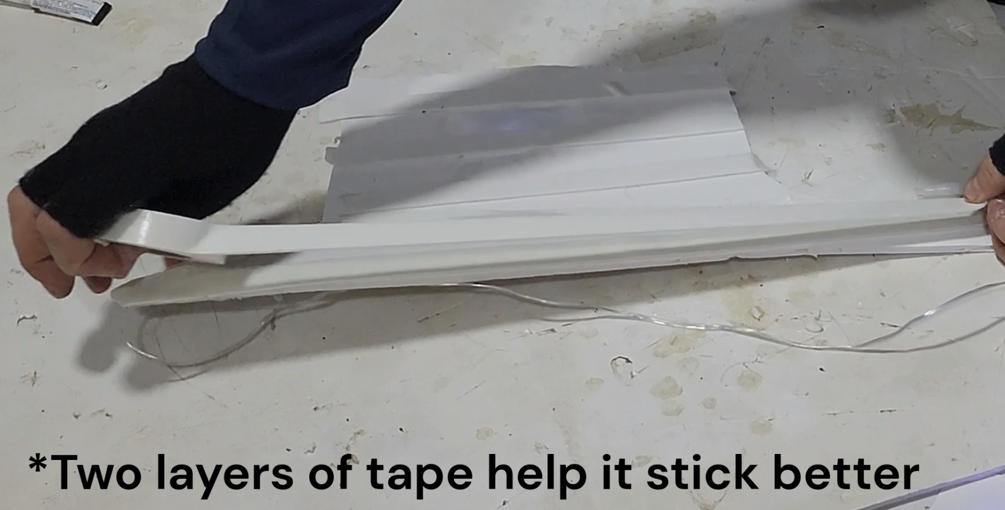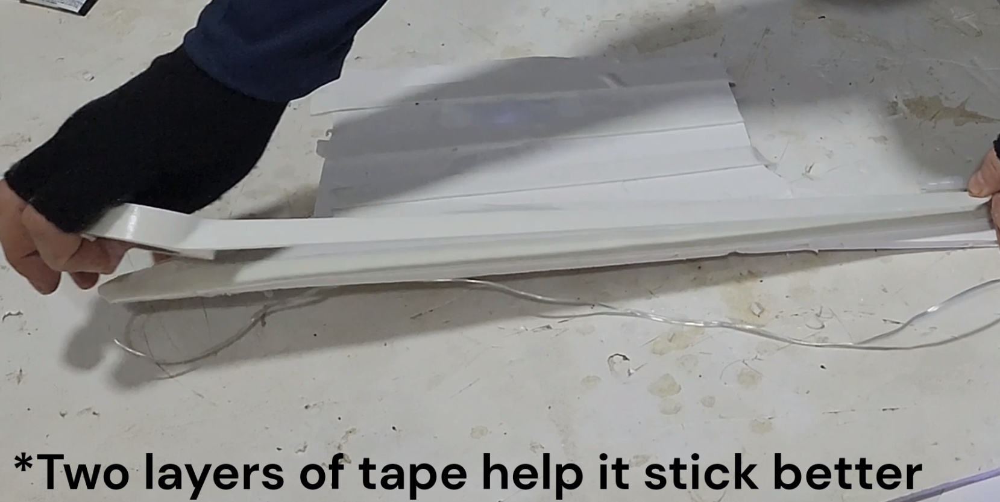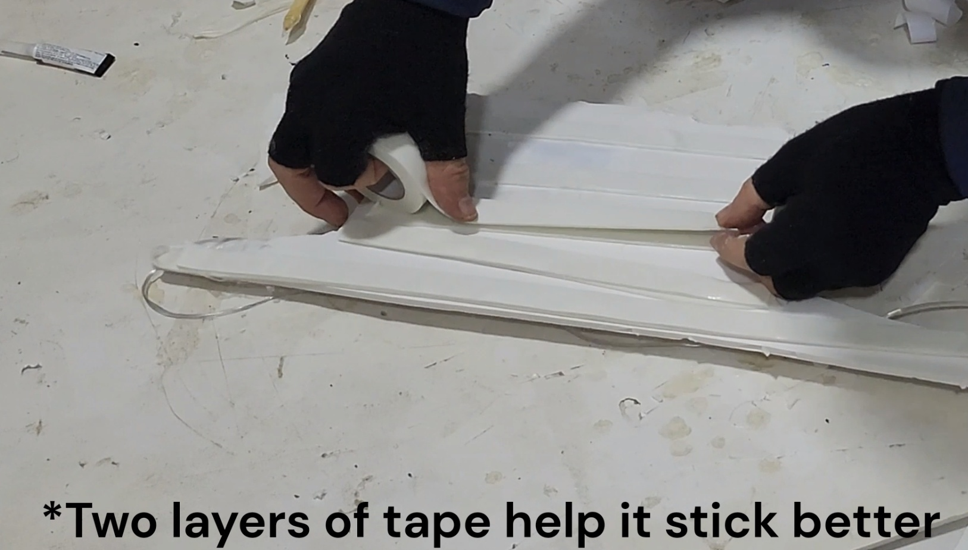

Sticking/Hanging the plate on Wall
Hanging is relatively straightforward. 1) uncover the double-sided tape on the back of the plate. It is possible to add some glue on the back to improve the long-term durability of sticking but how much durability this adds is unclear.
Hanging the plate on the drone is better done once the drone is in the air, as the drone tends to be unstable at liftoff with a payload attached.
Fly the drone to the target and push the plate into the wall. For AIR 3 flying backward seems to be more stable for some reason. Once pushed to the wall the plate should be stacked firmly stuck. Move the drone directly downward and release the plate. If the drone doesn't move down and is stuck on the plate you can try playing with pushing the drone to the wall and moving downward at the same time, this always works.
First few tries are better to practice on low walls next with soft ground so you can do it consistently without crashing. It's always possible to remove the plate from the wall, add a new layer of double sided tape and use it again. Although this will often remove the paint and plaster from the wall in the process.

Att Video: https://www.youtube.com/watch?v=-RfBEk50M3s
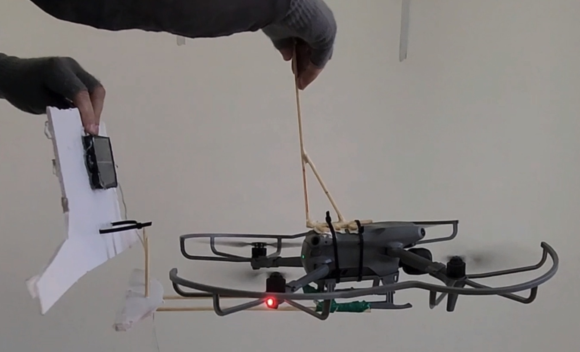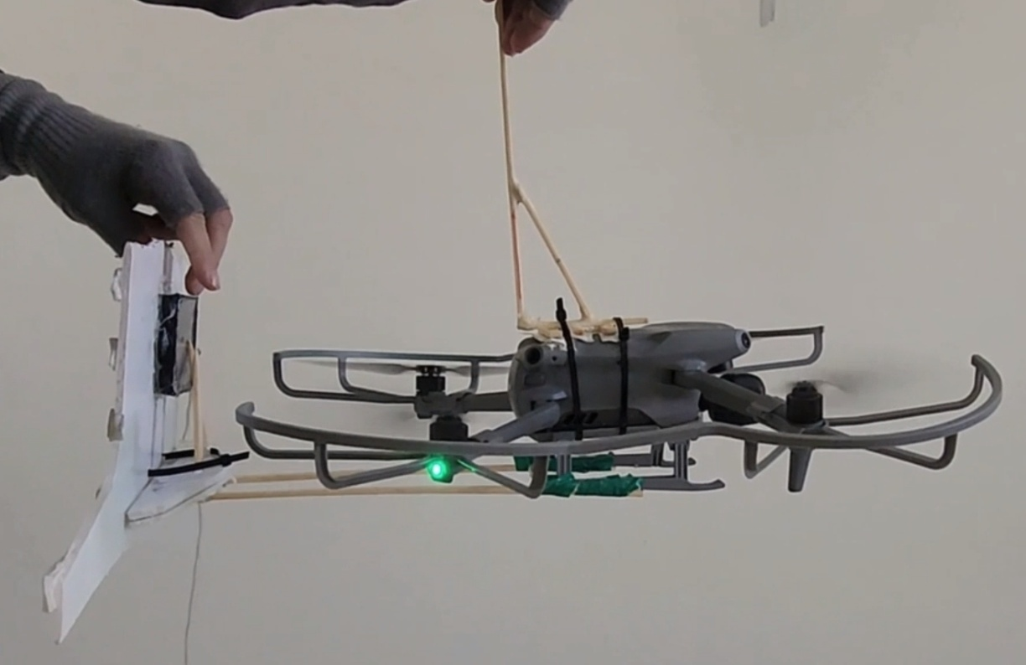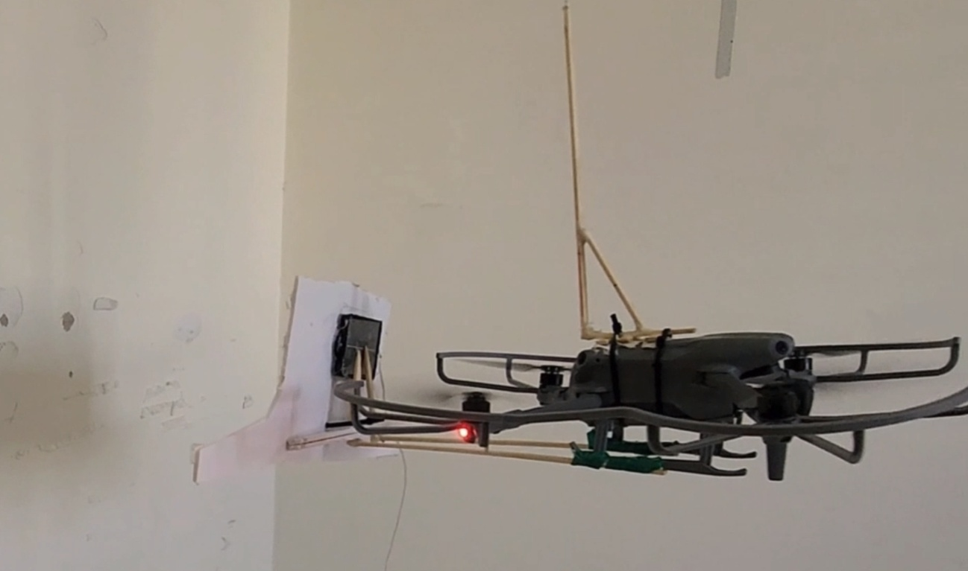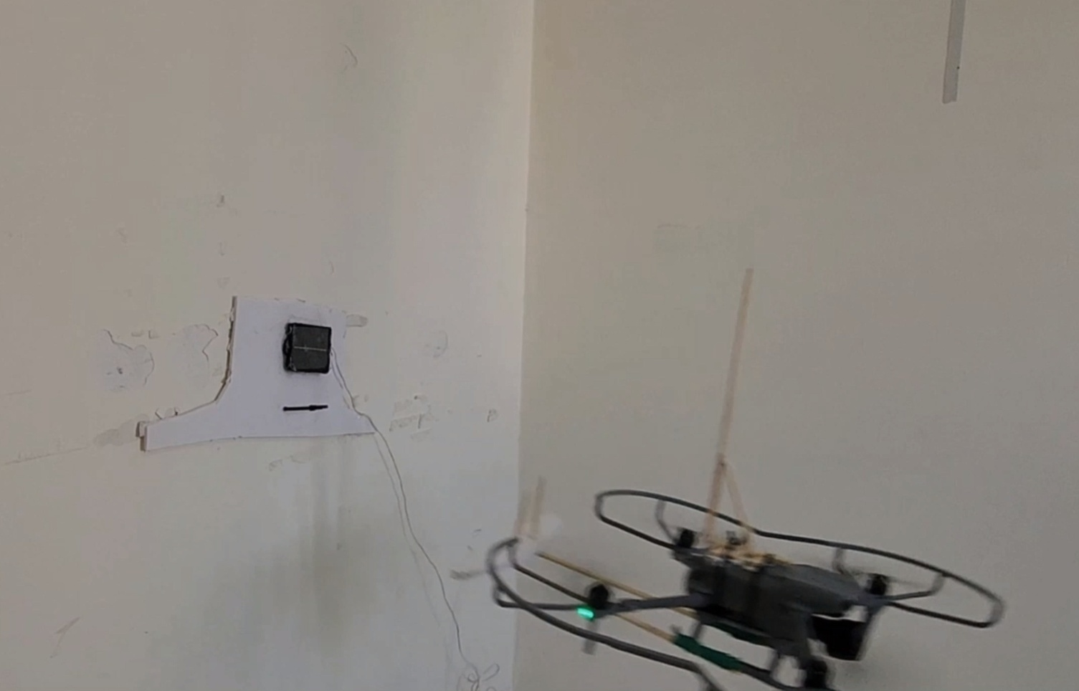

Troubleshooting

Unstable flight mean few things:
- To much weight
- Plates hang too loosely and destabilize the drone.
- Plate too big or two tilted and block air flow to the propeller.
- Worn out propellers that should be replaced or propeller guards that block air flow too much.
- Wind has a significant effect in high altitudes, large plates act like a sail.
If the plate does not stick:
- Not enough double sided tape, or too thin tape that doesn't stick to rough surfaces, Adding more layers of tape one on top of the other usually works.
- Loop is too tight around the hook and the drone can't move without reaping the plate.
- Plates hang in problematic angles on the drone and are not pushed to the wall across all surfaces (should be close to vertical).
Drone doesn't detached from plate:
- Loop is too tight, try move push to the wall and move downward in the same time
- Hook or hook plate is too rough and friction prevents the drone from moving, try wrapping smooth duct tape and make things smoother and easier to slide.

